Sample Safety Program:
Hazard Identification and Risk Assessment

Insert Company Name
Hazard Identification and Risk Assessment
(Job Safety Analysis-JSA)

Purpose

The purpose of the Hazard Identification and Risk Assessment (Job Safety Analysis) Program is to prevent exposure to hazards associated with any type of work we perform. (Insert Company Name) uses the JSA process to identify hazards associated with routine and non-routine tasks and to conduct risk assessments.

The hazard identification process should be used for routine and non-routine activities as well as new processes, changes in operation, products or services as applicable. All employees will be trained in the JSA process and Hazard Identification, and the use of all PPE required at the time of hire and refresher training annually. The JSA will be reviewed and discussed with all employees before work is started. All corrective measures shall be reviewed for any new hazards created by the corrective measures. If hazards are identified, they must be corrected or eliminated before work can began.

The Job Safety analysis involves two elements to achieve the purpose of eliminating hazards.

- One element is to evaluate the tasks we perform to determine the steps necessary to complete the task, assess the hazards associated with the task and determine the safety precautions necessary to mitigate the hazards. All identified hazards are classified and prioritized and addressed based on the risk associated with the task (Risk Analysis Matrix outlining severity and probability). All identified hazards must be addressed and mitigated. Site supervisors will dedicate assignment, complete appropriate documentation of completion, and implemented controls.

- The second element is to assess work specific sites (tailgate safety meetings) immediately prior to work to address issues unique to that site at that time.
Application

This process applies to all company personnel, both employees and subcontractors. (Insert Name) is the company’s designated safety representative and will maintain this program as well as the accompanying JSA documents. He/she will also ensure the JSA forms are being properly completed and followed.
Overview

This process will continually evolve. We will continue to commit more and more Job Safety Analyses to print and the analysis’ we have completed will continue to change as new work practices and equipment are identified to perform tasks more safely.

Job Safety Analysis is a process of documenting an evaluation of work we perform.
Application

Company personnel will conduct a job safety analysis (JSA) each time they perform a task. The JSA will be documented if the task is Non-Routine.
A. A Non-Routine task is:
- Any task that is not performed regularly in a field, OR
- Any task performed in a field not done at least weekly.

B. The company will use the Think Incident Free (TIF) thought process to conduct our job safety analysis (JSA).
- Plan the job (define the steps, assess risk, mitigate the risk)
- Use the right tools the right way
- Verify those involved are trained for the job
- Have the right state of mind

C. If jobs require a written permit; the permit will serve as the Job Safety Analysis. Tasks that require a permit include:
- Entry into confined spaces
- Hot work as defined in the Company Hot Work Program
- And some excavations

D. The JSA process has two components for “non-routine” tasks on one form:
- Completion of a jobsite or task assessment.
- Completion of a JSA if a written JSA is not on file.

E. Conducting a Job Safety Analysis for Routine tasks.
- Use the Think Incident Free (TIF) thought process to:
      - Review the steps of the task
      - To verify current conditions
      - Verify knowledge and training
      - Verify the proper tools are available
      - Remind yourself to step back and start the process over if conditions change or if the scope of the job changes
- If the initial JSA indicates conditions exist that make the task Non-Routine, then conduct a documented jobsite assessment. Document a JSA for the work if one has not yet been completed.

F. Conducting a Job Safety Analysis for Non-Routine tasks.
Job Safety Analyses must be documented for Non-Routine tasks. Tasks or activities are Non-Routine if you do not perform them at least weekly OR if you do not work in that field at least weekly.
- Complete the front of the form which is a site assessment with respect to the task to be done.

- If a written JSA exists, review it and continue the job. If a written JSA does NOT exist for your review, then complete the JSA using the back of the form.

G. Contractors completing Job Safety Analysis.
Contractors are also required to conduct job safety analysis if they are working for the company. To assist them in considering all risks associated with the site, inform them of unique issues at a work site. Information would include:
- Industrial hygiene information regarding (Enter specific material information here: Examples: H2S, NORM, asbestos, lead, etc.)
- If digging is to be done; location of lines
- Locations of valves, etc.
- Other information contained on the site assessment form if it is applicable to the site or work to be done.

The program must provide processes to ensure employees and sub-contractors are actively involved in the hazard identification process and hazards are reviewed with all employees concerned.

Example JSA Form

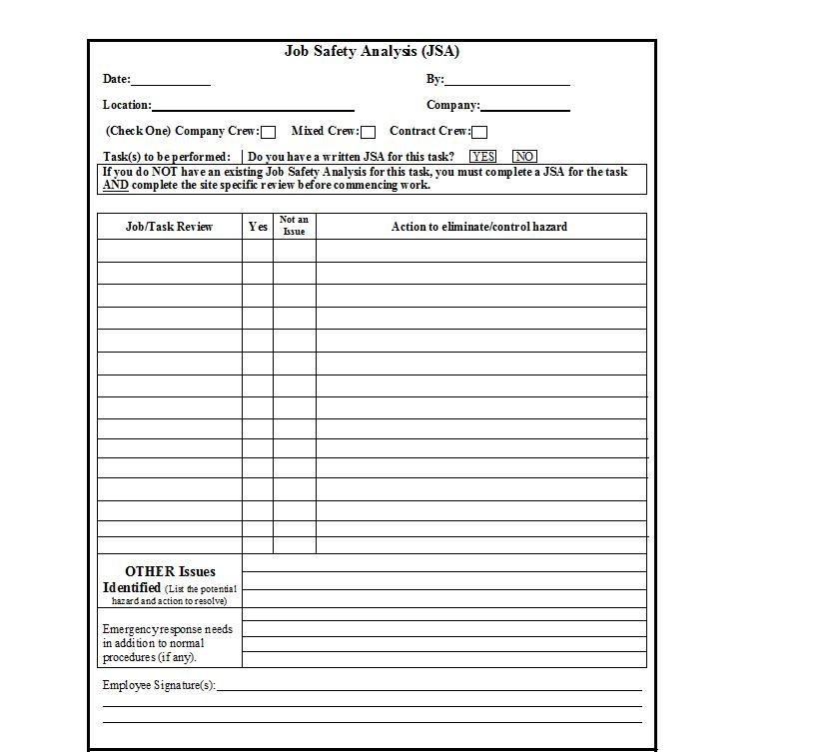

Insert Company Name
Hazard Identification and Risk Assessment
(Job Safety Analysis-JSA)

I, have received training on the hazard identification and risk assessment requirements, procedures and applicable JSA forms. I have asked and received clarification on all questions regarding this program. I understand that my failure to follow the requirements outlined in this program may result in disciplinary actions, up to, and including, termination.

___________________________________________________ _____________
Employee Signature Date

__________________________________________________ _ _____________ Supervisor’s Signature Date

