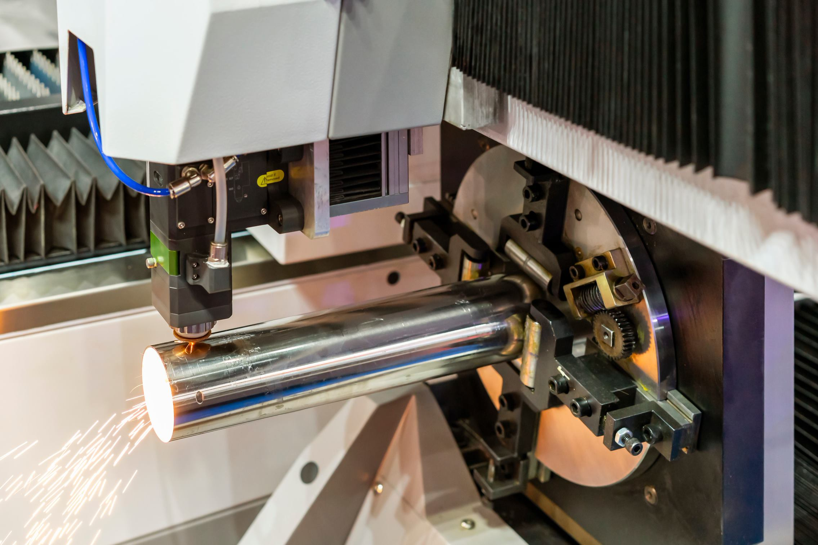
Plasma Pipe Cutting Machines with Conveyors
The use of plasma cutting machines in shops is associated with several potential hazards. Adding an entrance/discharge conveyor increases the number of potential hazards. The machines are, however, safe, efficient, and effective when used properly.

Working safely with plasma cutting machines requires the following safe work practices:

- Wear safety glasses with properly shaded lenses at all times.
- If you will be standing near the cut, wear a face shield to protect your face from the sparks.
- Always wear proper PPE.
  - Wear welding gloves, flame-resistant clothing, and steel-toed boots.
- Whenever you handle gas cylinders, always keep in mind their extreme pressure. Even though the gas used for plasma cutting is non-flammable and stable, the explosion could still occur if the cylinder is heated.
- Make sure the shop is adequately ventilated before you start to work.
- Inspect the machine before you start to use it.
  - Ensure that there is no apparent damage to the machine, that the gas hose and nozzle are in good condition, and that there are no gas leaks in the system.
- If anything looks out of place, do not use the machine.
  - Immediately follow your company procedures for taking defective equipment out of service.
- Remove any flammable/combustible materials from the immediate work area before you start to work.
- Ensure no one else is near the machine before you start the process.
- When using a conveyor, pay close attention to the process to carefully control the pipe and ensure that it is properly received at the discharge end of the conveyor.
- Always be thinking about proper hand placement.
  - The pipe and the conveyor create hazardous pinch points when the pipe is moving.

