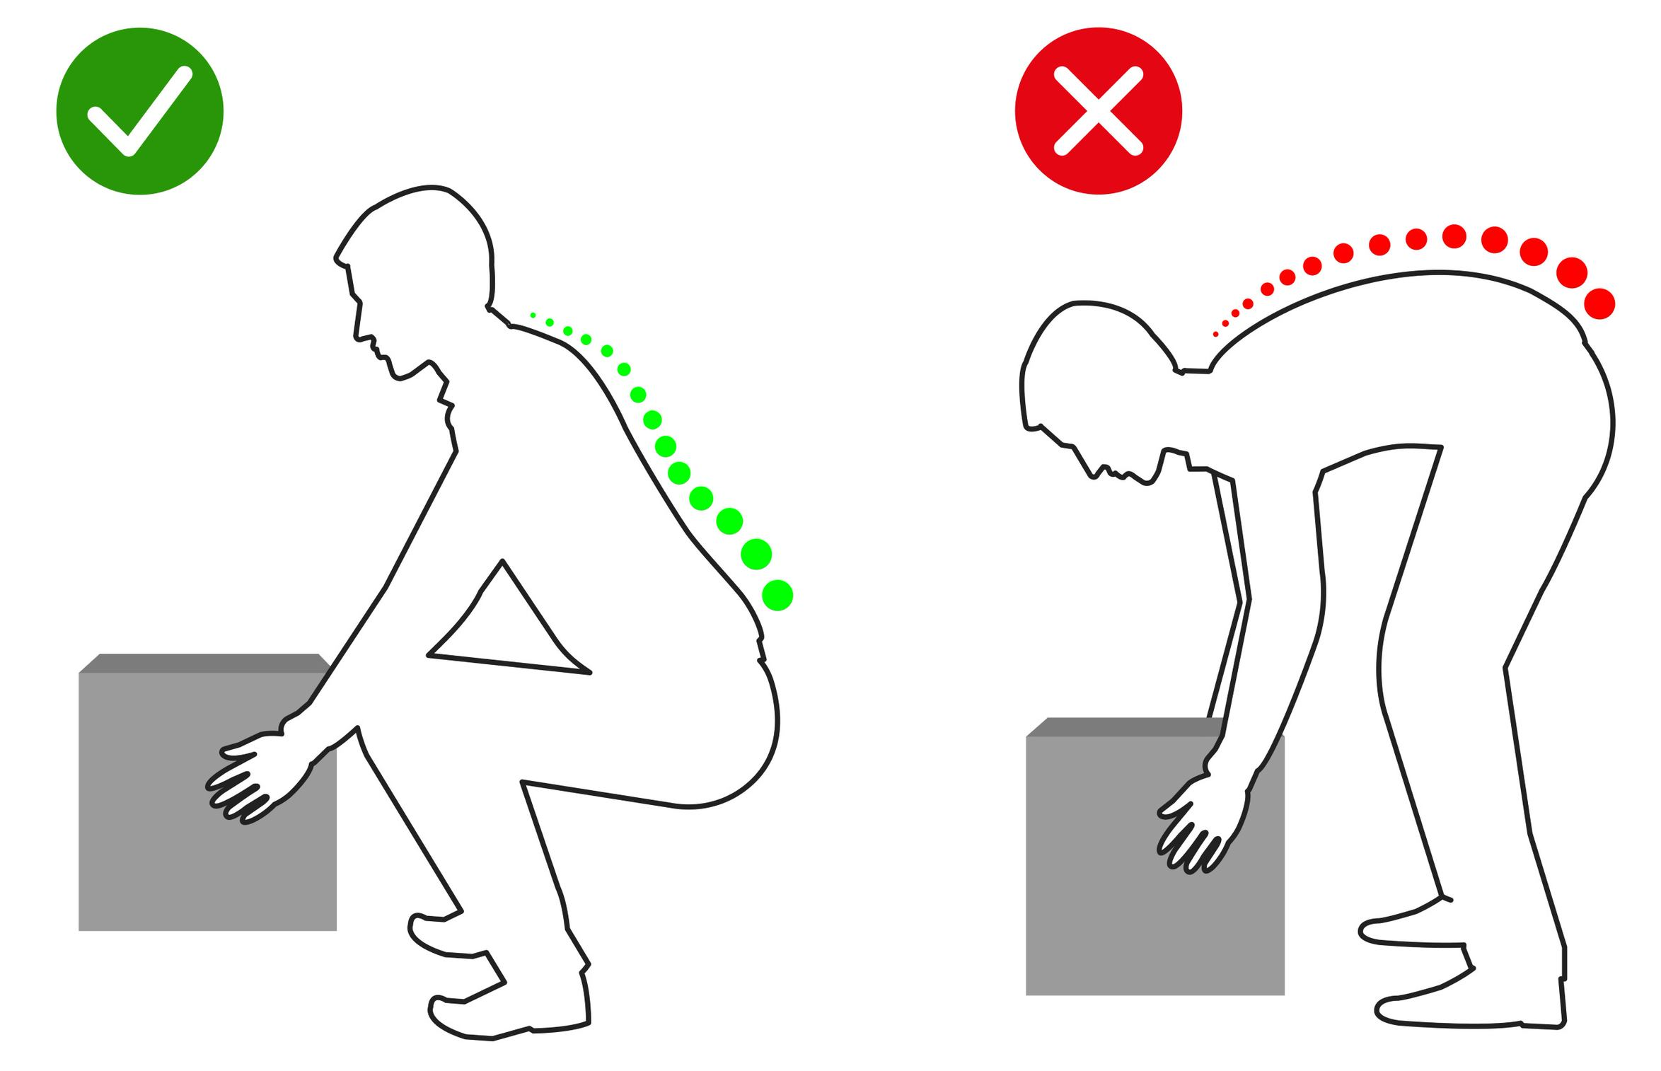
Moving Materials and Equipment
In shops, it is a daily requirement to move materials and equipment. Every day, shop workers are injured because they improperly handle materials. However, it is possible to protect yourself when moving materials and equipment if you follow a few key steps.
The following are safe workplace practices to help you protect yourself when moving materials:
- Material from delivery trucks and boxes should be unloaded as close as possible to your immediate work area.
- Whenever possible, keep pipe fittings and other materials off the ground.
  - The most efficient way to store materials that aren't too big or too bulky is on pallets, in mobile racks, on tables or shelves at waist height.
- The most efficient way to store materials that aren't too big or bulky is on pallets, mobile racks, or tables or shelves at waist height.
- Never lift and move materials that can be moved by some other means.
- Always use proper lifting techniques:
  - Directly face the object.
  - Get as close to the object as you can.
  - Bend your knees.
  - Get a firm grip on the object.
  - Stand with your feet shoulder-width apart.
  - Bend at your knees and hips.
  - Use your legs, not your back, to raise your body and lift the object slowly.
- When you are carrying an object, never twist your torso.
  - Move only your feet to change direction.
- Wear cut-resistant gloves to protect your hands when working or moving sheet metal or sharp edges on pipes.
- If you are moving materials, think about where you will place your hands so that you don't pinch or crush them.
- Efficient material handling in your shop increases productivity.

