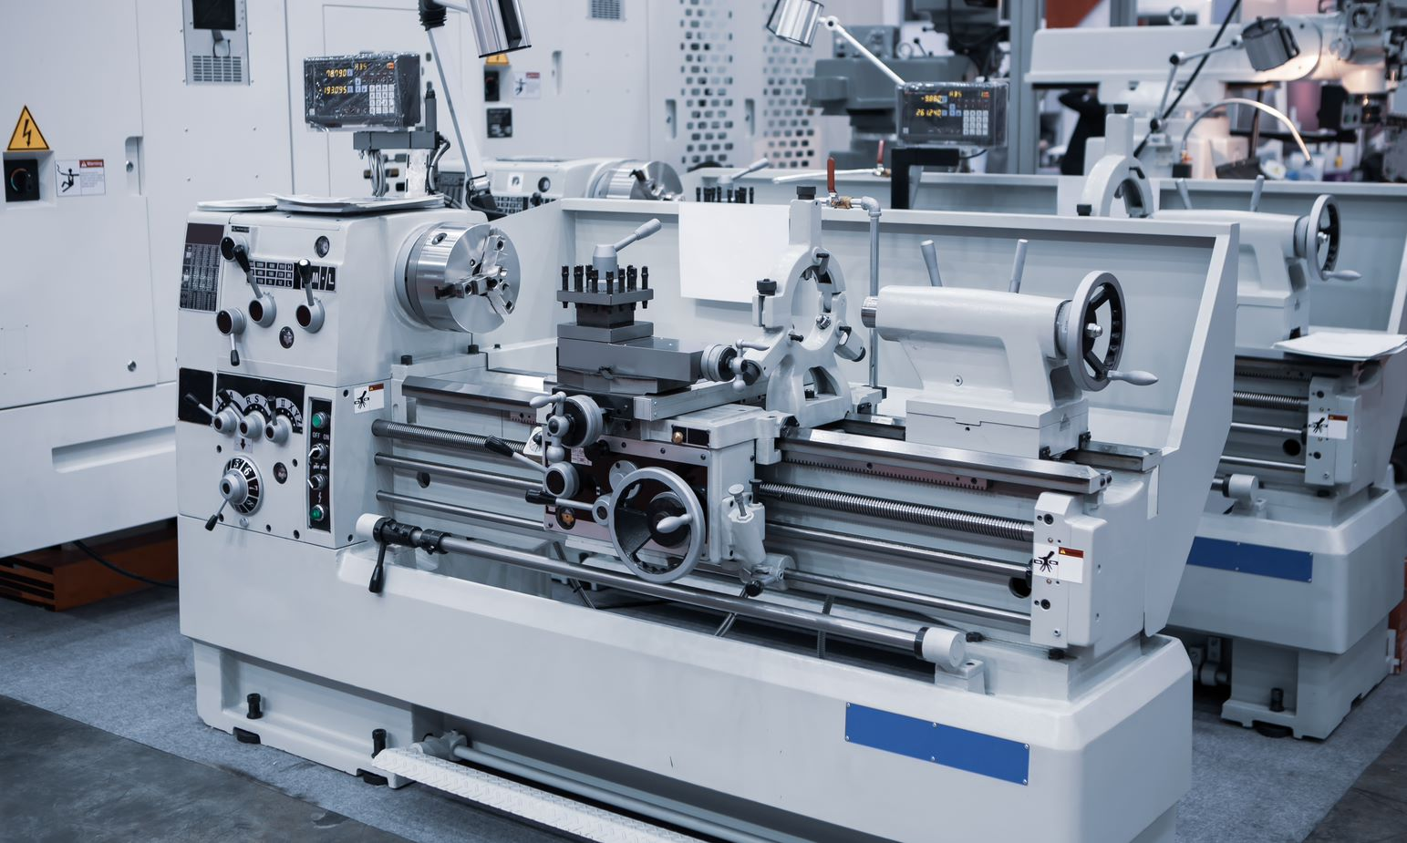
Lathe Safety Talk
Lathes are helpful equipment for employees in the manufacturing industry, but employees must take the necessary precautions when using them to prevent workplace injuries and accidents. One of the most common hazards when using lathes is entanglement.
To ensure safe lathe use, consider the following tips:
- Be sure that the start/stop button is within easy reach of the operator when running the lathe.
- Ensure that the emergency stop button is working correctly.
- Ensure that all cutting tools on the lathe are sharp.
- Maintain a clean working surface and floor around the lathe.
- Wear appropriate PPE.
  - Proper PPE includes safety glasses, ear plugs, protective footwear, avoid loose-fitting clothing and jewelry.
- Practice good housekeeping at the end of the shift and clean the chips off the floor so they do not become a slip hazard.
- Ensure that guards and shields are in place.
  - Use clear guards so that everything can still be seen.
- Do not use a rag to clean the machine or work while in operation
- Always remove the chuck key after use

Employees who use lathes should also avoid the following bad habits:
- Do not lean on the machine.
- Wait until the lathe has completely stopped before making any adjustments.
- Keep your hands away from the turning work in the machine.
- Avoid using calipers or gauges on a piece while the lathe is running.
- Do not make heavy cuts on long, thin pieces of material, as this could cause it to bend and be flung from the machine.
- Do not leave a lathe running unattended.
- Do not horseplay around the machine.

