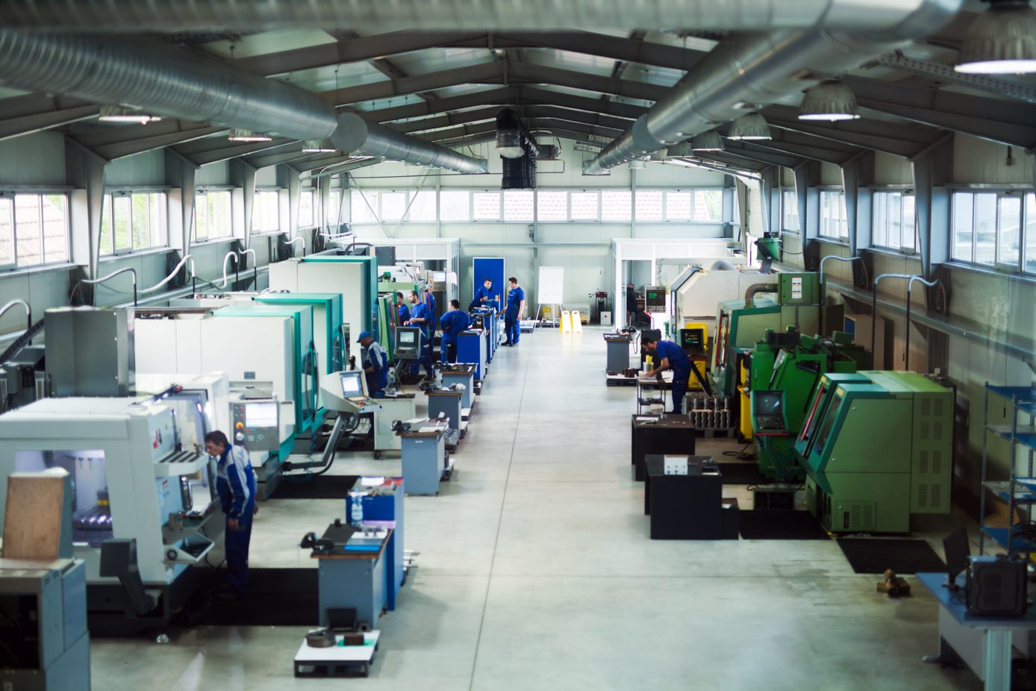
General Safety for Machine Shops
The following are common, important safety guidelines to remember when working in a shop environment. Follow this shop safety checklist:
- The shop equipment should not be used by someone who has not been properly trained.
  - Do not allow unauthorized persons to visit or loiter in the shop.
- Keep the shop secure when no is present and never leave the machine running unattended.
- Ensure that emergency equipment, such as first aid kits, emergency lighting, fire extinguishers, and eyewash stations, is checked monthly.
- All power tools, hand tools, and large shop equipment should be inspected periodically.
  - This is a great time to replace worn or damaged cords, guards, and other damaged equipment, such as a scratched face shield.
  - The self-closing covers should be thoroughly checked for proper ventilation, lighting, and fusible links.
- For proper shop maintenance, follow these guidelines:
  - Spills should always be cleaned up immediately.
  - Ensure that walkways and stairs free are free of tripping hazards.
  - Keep oily rags in a covered metal container and dispose of them every night.
  - Shop machinery should be periodically cleaned of excess cutting oils and filings.
  - Retain all tools in their place and mark the ones that require repair with a red tag.
- Never wear jewelry or lose clothing around rotating machinery.
  - Avoid getting entangled with long hair or any other item that may become entangled.
- It is important to follow all the proper steps when utilizing a lockout/tagout procedure.
  - Do not cut corners because you think it’s going to save time.

