Drill Press 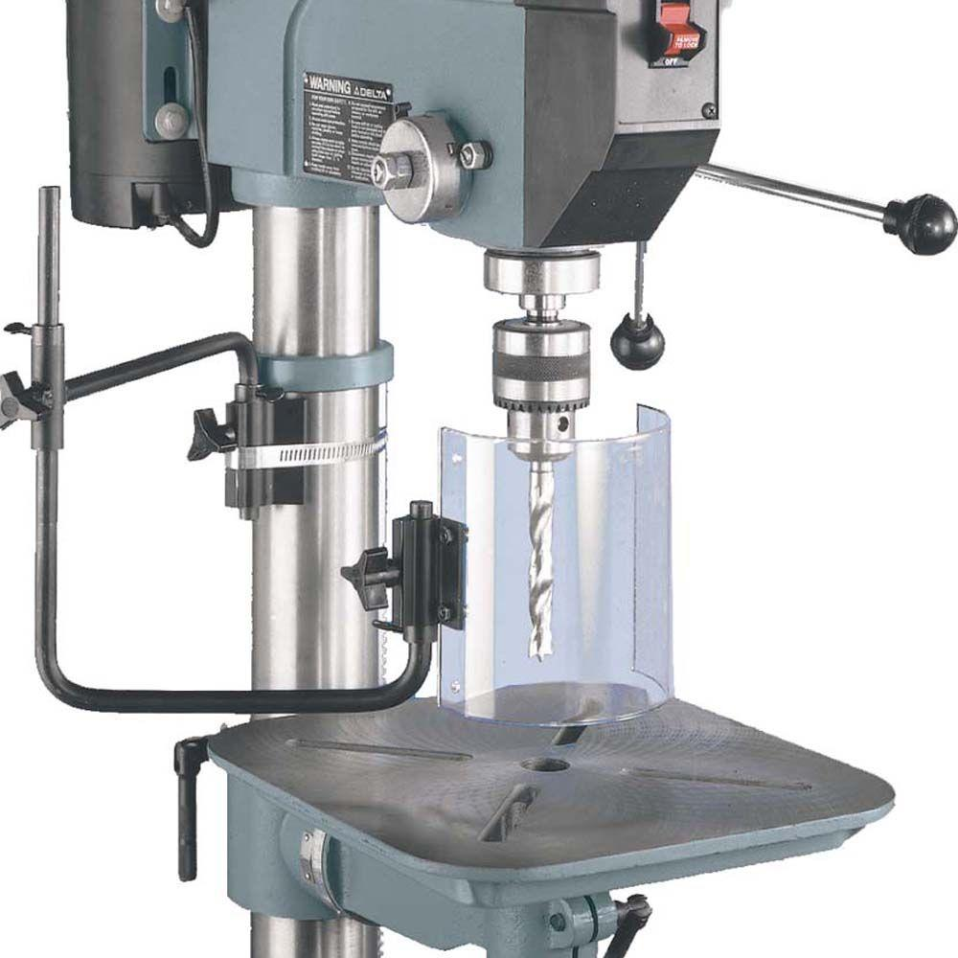
It is not often that drill presses are associated with horrific shop injuries, but they have far more power than most people realize. Several hazards may be encountered, including hand and finger contact with the bit, flying particles, flying objects such as broken bits, and objects getting caught up and pulled into the rotating bit or chuck. In most cases, drill press manufacturers do not provide a guard to prevent contact with the bit or chuck.
General safe word practices to help you protect yourself from the most common drill press hazards follow:
- When using a drill press, wear safety glasses and cut-resistant gloves that fit snugly, but do not wear loose-fitting gloves, clothing, jewelry, or anything else that could catch on the rotating bit or chuck.
- If your company has purchased a guard, make sure it is properly secured in place.
- To prevent the bit from making contact with the drill press table, use wood backing to prevent the bit from breaking if enough pressure is applied.
- To ensure the bit you will use is correctly inserted into the chuck, the chuck key must be adequately tightened.
  - Be sure to remove the chuck key from the chuck before you start the motor
- Ensure the drill press table is adequately secured to the material you will be drilling into. Use a suitable clamp or vise.
  - When drilling into a cylindrical object, such as a pipe, use a V-shaped block to prevent it from rolling.
- Drill bits can get stuck, so don't force them; they'll break and go flying.
- The bit can be freed by turning the chuck backward with a gloved hand after the drill press has been turned off and the chuck has come to a complete stop.
- Always turn the drill press off and wait for the Chuck to come to a complete stop before reaching, to make adjustments to the material, or to grab the chuck.

