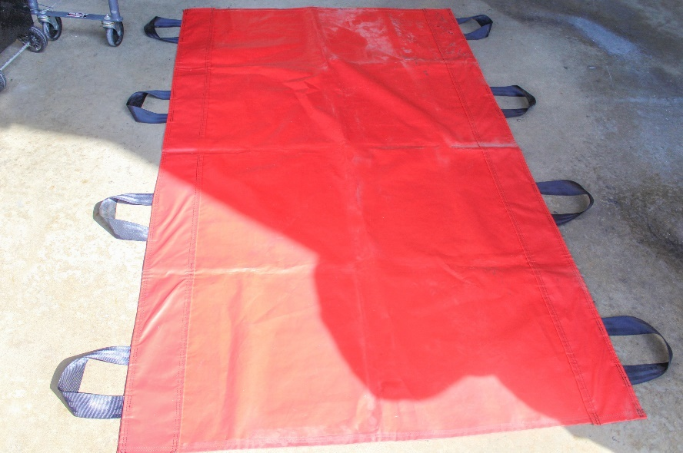
You can transfer or move a client from one place to another in numerous ways. Emergency personnel move patients in and out of a confined space, which can be difficult. In tight or small spaces, it might require using materials such as tarps, often referred to as Mega Movers, for safely assisting with moving a client. The use of tarps aids first responders when they must work in tight spaces where backboards or gurneys might not fit. When using a tarp, keep the following tips in mind:
- Select the right material
Mega Movers can be made of materials ranging from polyethylene, cotton canvas, and waterproof vinyl. When selecting a tarp, be sure it meets the needs of how it will be used. Handles should be rated to withstand weight limits to prevent injury or mishaps.
- Use at least two people
When using a tarp to move a patient, be sure to have two, preferably three, helpers to assist.
- Roll the patient from side to side to position them properly
Follow the same procedure to move the patient as you would if changing a bed sheet. Rolling the patient from side to side while you place and pull the tarp underneath their body to get them into the middle of the tarp.
- Team lift – communicate
Verbalize your actions when you lift. Lift with me on 1-2-3 to ensure helpers cooperate to move the patient safely.
- Proper clean- up and storage
Clean the tarp with disinfectant, soap, and water after each use to keep equipment ready. Review the manufacturer’s recommended guidelines for proper cleaning and storing to prolong the lifespan of the tarp. When clean, return the tarp to its storage place, so it’s accessible for the next use.
- Inspect regularly
As with any equipment, inspect the tarp for wear and tear to replace as needed.

