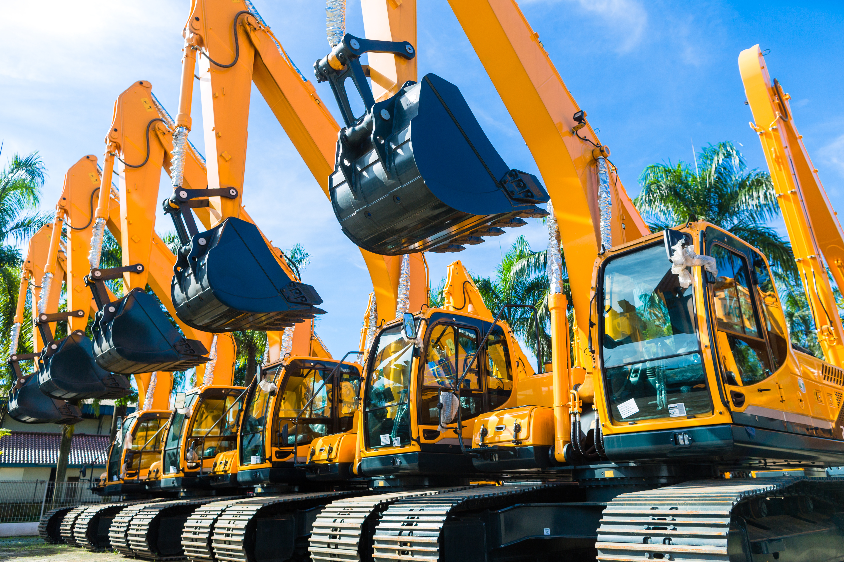
Importance of Heavy Equipment Safety
The operator of heavy equipment and those who work around it face both power and danger. The size, weight, and complexity of heavy equipment make it dangerous. Working near heavy equipment requires the operator and coworkers to share safety responsibilities. It is possible to create hazardous situations by neither operating the equipment safely nor being around it safely. The equipment can cause severe and sometimes fatal injuries to workers if it strikes them or rolls over.
Things to be aware of:
- Before an operation, inspect the equipment to ensure that all warning systems, including lights and audible alarms, are working correctly.
- Ensure communication (hand signals, radios, air horns, audible alarms, etc.) is set up before work begins.
- The worker, spotter, and operator should maintain a clear line of sight.
- It is common to have blind spots, which can be eliminated by using mirrors and cameras.
- Don't forget that if you can't see the operator, they can't see you.
- When heavy equipment is in motion, use a spotter.
- This requires communication between the operator and workers to maintain safe movement.
- If one loses contact (visibility or communication) with the spotter or someone close to the operational zone, the operator must cease all activities until contact is reestablished.
- If possible, cordon off the area with barriers or caution tape if specific equipment has a wide swing radius.
- There shall be no riders, only equipment designed to carry more than one person shall have more than one occupant.
- Wear high visibility clothing for outer garments and the proper PPE.
- Ensure you are properly trained and approved before working under any suspended or overhead loads (i.e., connectors, etc.).

