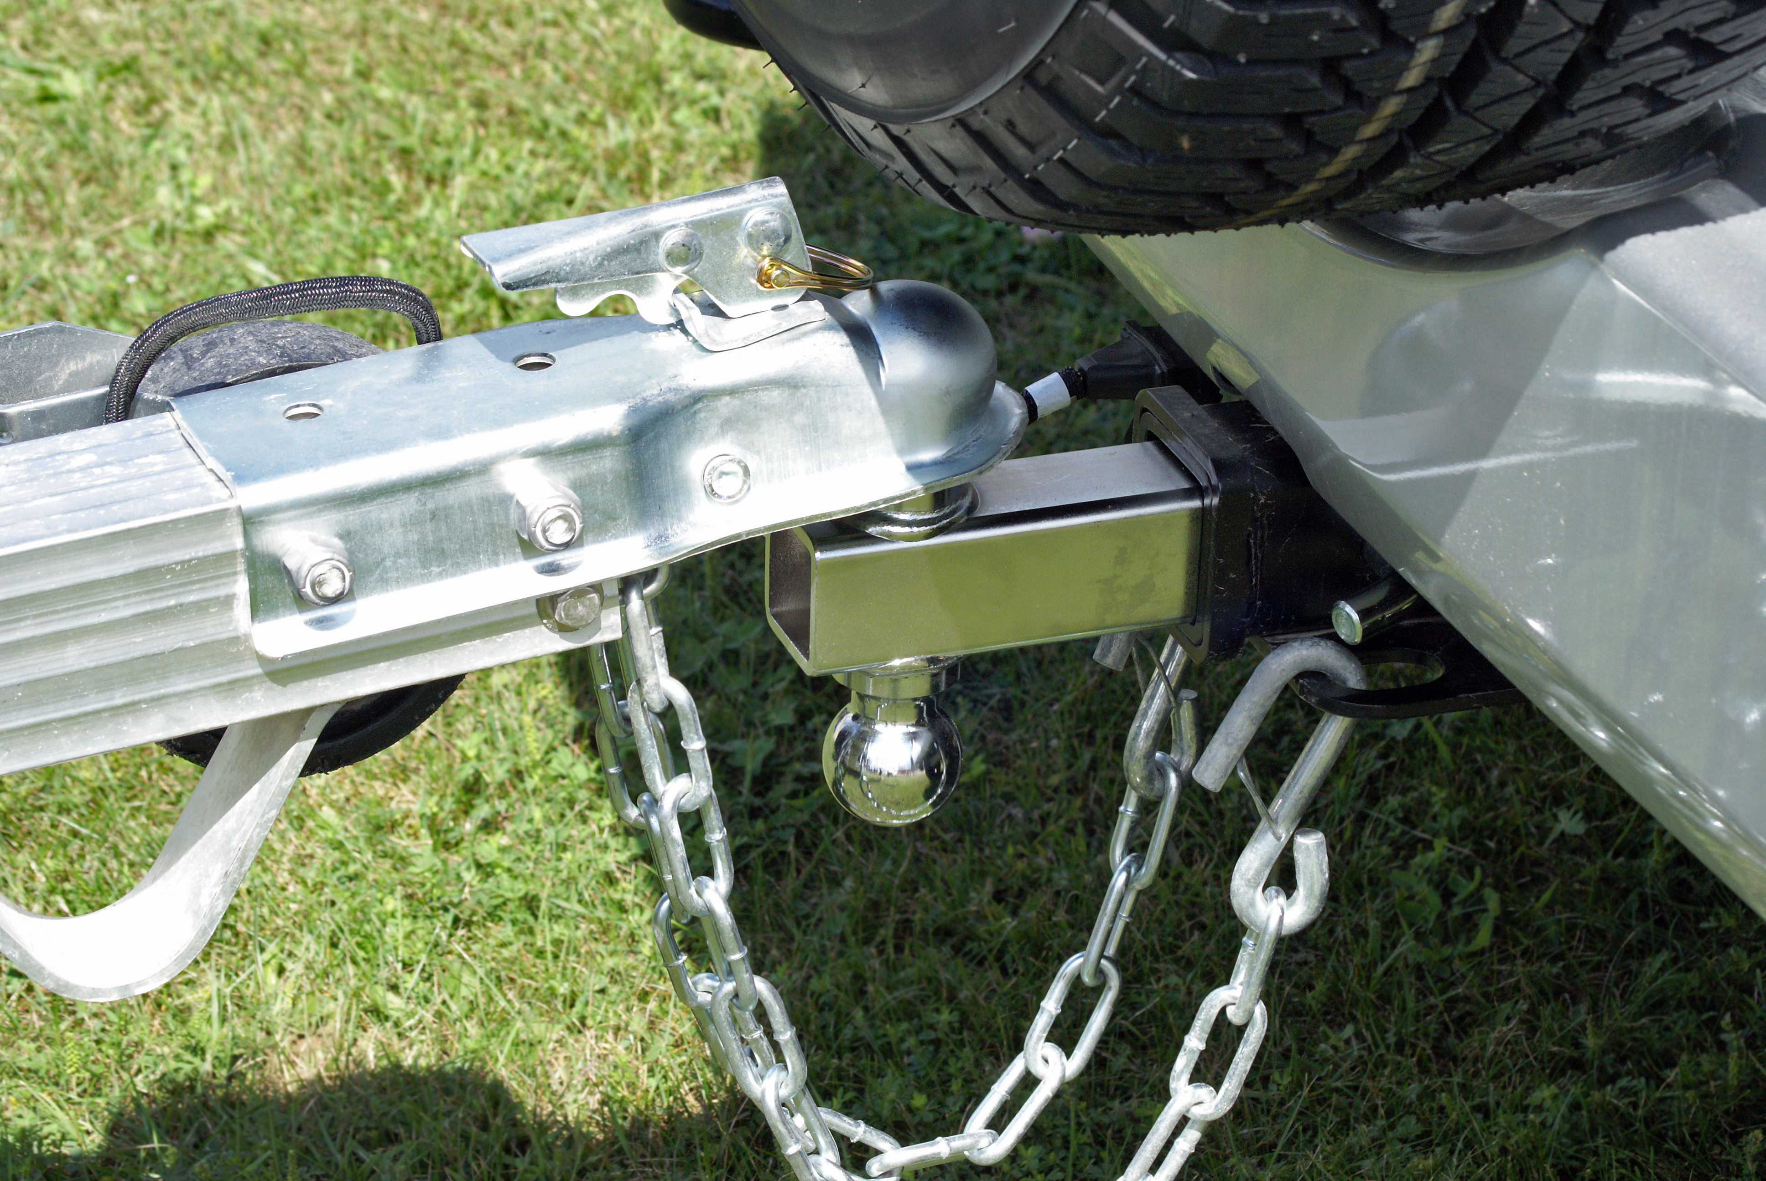
How to Properly Use a Hitch
Hitch devices are used to connect a trailer to a vehicle. Tow vehicles come equipped with a towing bumper that eliminates the need for a receiver since the hitch ball can be attached directly to the bumper. For safe towing, the bumper indicates the tongue and trailer weight. Tow vehicles may also require a receiver attachment or hitch.
Hitching using a ball mount system:
- It is important to ensure that all parts of the hitch system are in proper working order.
- It is necessary to make sure that your trailer's hitch/receiver, ball mount, coupler, safety chains, and cables are adequate to handle the trailer's weight. To ensure safety, each component must have a GVWR of at least as much as the trailer's GVWR.
- It is important that the ball mount matches the coupler so that it fits properly. On both the ball and the coupler, the size should be clearly marked on the part.
- To ensure your trailer is parallel to the ground when loaded and towed, make sure the ball mount is at the correct height.
- If not permanently affixed, attach your ball mount according to the manufacturer's instructions.
- Attach the coupler to the ball mount according to the manufacturer’s instructions.
- Attach the safety chains from your trailer to your tow vehicle.
  - Under the tongue of the trailer, the chains should form an X so they would catch the tongue prior to contacting the ground in the event the trailer disconnected from the tow vehicle.
  - Each chain shall be rated for the trailer's GVWR and have a separate attachment point to the towing vehicle.
- Connect any pin connectors for lighting and, if applicable, brakes.
- Ensure your trailer lights are in working order.
The trailer/towing system's maximum capacity is never greater than the lowest rated part. Therefore, the trailer's weakest link should be rated at least as high as its GVWR. The hitch system on your trailer should also be in good working condition and match the tongue type on the trailer.

