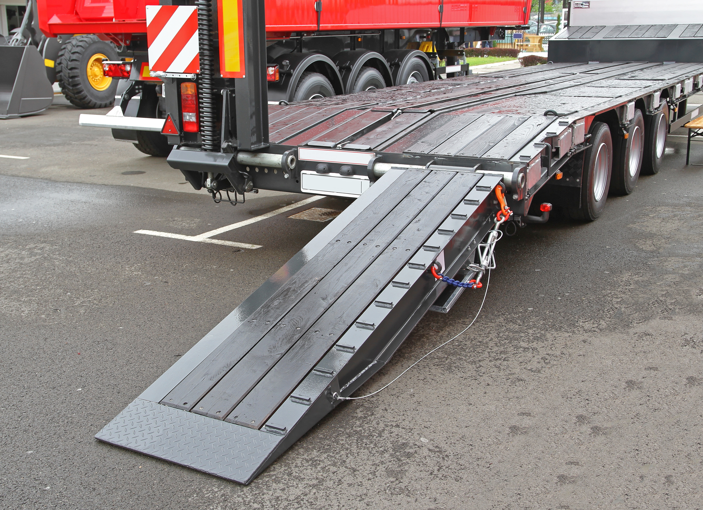
Loading and Unloading Trailers
Although loading or unloading a trailer can be straightforward, several factors must be considered. The preparation of any task is crucial to ensuring its safety and efficiency. Regarding loading and offloading trailers, there are plenty of hazards to be aware of. The specific risks posed by the task will vary depending on the worksite set-up, equipment used, materials being offloaded, trailer type, etc. Below are common hazards during unloading:
- During loading and unloading a trailer, struck-by hazards are a significant concern. Struck-by hazards include the actual load or moving equipment.
- Slips, trips, and falls also are a concern. It poses a fall hazard to those helping to load or unload the trailer by climbing on and off. Poor housekeeping or equipment on the ground, such as straps or chains, can pose many trip hazards.
- Pinch point hazards are also common while loading or unloading trailers. It is common to encounter pinch points when lifting objects and staging materials on site.
- Caught-in or between hazards are present whenever heavy equipment is moving, or the load is being moved.
Preplanning and communication are critical to ensure a smooth loading or unloading process at the job site. Two significant things to consider:
- The load itself
  - How each trailer is loaded and what is showing up on it. To safely load or remove the load from the trailer, what tools, equipment, and personnel are needed?
- Driver expectations
  - What are the expectations of the truck drivers coming onto the site? Some items that need to be discussed with the truckers delivering materials include entry point to the site, delivery times, speed limits, escort requirements, personal protective equipment requirements, truck and trailer requirements, phone numbers, hazards, etc.
  - The drivers should review and sign the document when they arrive on site. The drivers at your worksite should be informed of the importance of safety.

