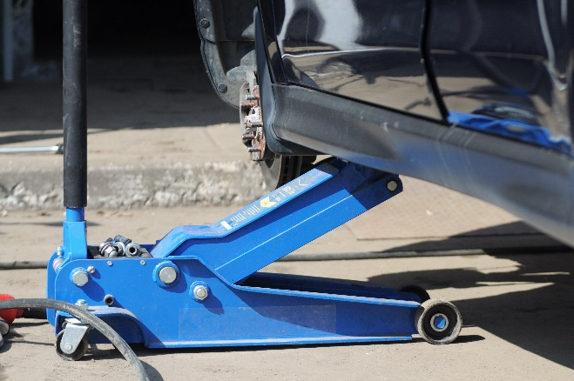
Proper use of jacks
Floor jacks are very important and are used all the time. Floor jacks help us lift heavy objects and vehicles with a few pumps or twist on the handle. It can be very easy to forget how much weight is being suspended by the jack, so it is important to think before you act. Always take your time to ensure that we are working as safely as possible. The following steps will help you stay safe while working with or around jacks.
- Support the load that is being with blocks or stands
- Always inspect your jack before use and before placing into storage
  - Never use a jack that is broken or seems to have something wrong
- Never allow raised vehicle to remain supported by jacks alone
- Ensure that jacks are in good working order before use
- Always ensure that the jack is placed in designated lift portion of the vehicle
- Always double check to make sure that the vehicle is parked on level ground and always double check that the transmission is in park
- Place solid blocks or stands under the equipment immediately after being raised
- Do not use cement or cinder blocks under the load
  - They could crack or shatter
- Always block the tires before jacking up the vehicle
  - This is to prevent it from rolling away
  - Use bricks, wooden wedges, or metal wheel chocks to block the tires
- Always obey the 80% rule
  - Do not exceed 80% of the maximum rating for load and stroke
- PPE can vary based on the type of jack; the following should always be used when using jacks:
  - Safety Glasses
  - Steel Toed work shoes or boots
- Never put a body part under a load until it is properly supported and solid
- Do not raise a load higher than necessary

