Hydraulic Lift Safety Talk
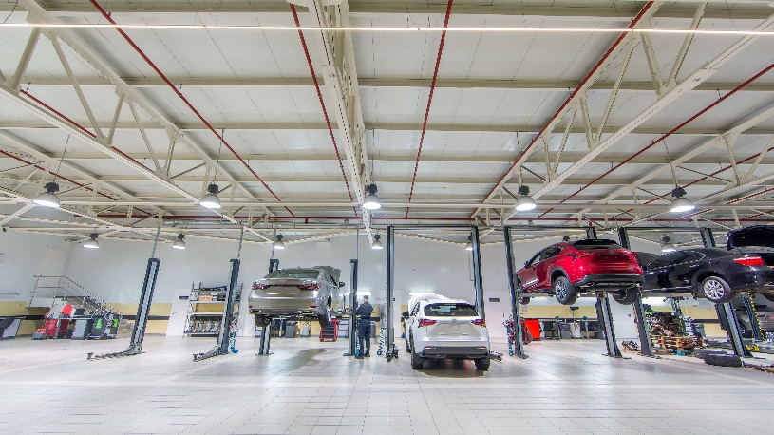
Hydraulic lifts are one of the most common tasks in an auto repair shop. They are lifted numerous times thought the day and it is a very critical task that needs to be performed in a safe manner. There is many hazardous associated with hydraulic lifts like risk to customer vehicles or even injury or death to technicians. Never get complacent while working around hydraulic lifts and always take your time.
Below are some tips and rules in order to stay safe when working around hydraulic lifts:
- Before you lift any vehicle, make sure that you are properly trained
- Check to make sure that your lift has been safely inspected by a qualified lift service person within the past year.
- Put your safety in your hands and always do your own check before using the lift
  - Make a daily examination of the cables and chains for wear
  - Ensure the safety latches are engaging and disengaging fully
- Once a month torque anchors to manufacturers spec’s
- Make sure to check the hydraulic fluid
- Make sure to check the torque of all fasteners
- Make sure to check the hoses for cracks or chafing
  - Change the hoses if you notice any cracks or chafing
- Never lift a vehicle that exceeds the maximum capacity of the lift
- Always know the vehicle lifting points when lifting a vehicle
- Before lifting a vehicle with a twin-post lift know the proper lifting points
  - The center of gravity of a front-wheel drive vehicle it is under the steering wheel
  - The center of gravity of a rear-wheel drive vehicle it is under the front seat
- Always chalk at least one wheel when the vehicle is on the lift
- Check the lifting points during the lifting process
- Always be aware and focused when lifting a vehicle
- If you must do any heavy lifting, pulling, or prying you must use four appropriate jack stands
  - Always raise jack stands to the height of the vehicle and never lower to the stands
- Never walk under the vehicle with the safety locks disengaged
- Blocks of wood or bricks are not proper lift accessories
- If you believe that there is a problem with you lift properly tag it out and do not use it until a qualified lift specialist has looked at it

