How To “Ring Test” a Grinding Wheel
Grinding wheels can be very dangerous. If a damaged wheel is over-revved, it may shatter, sending shrapnel everywhere and possibly resulting in injury. It is impossible to tell by visual inspection if a grinding wheel is damaged or not. Follow these guidelines for proper care and maintenance of grinding wheels.
A grinding wheel must first be inspected and "ring-tested" before installation to make sure it is free from cracks or other defects. Light, nonmetallic tools should be used to tap the wheels gently. When a wheel is stable and undamaged, it will have a clear metallic tone or "ring."
- Always check the spindle speed of the machine before mounting the wheel to ensure it does not exceed the maximum speed indicated on the wheel.
- When turning on the machine after mounting the wheel, stand to one side in case there happens to be a crack or defect.
- Make sure the wheel is dry and free of sawdust or other materials that could dampen the sound of the ring.
The test requires a hard plastic or hard wooden object, such as a screwdriver handle or another tool. For heavier tools, use a wood mallet. Do not use metal objects.
Below are the proper steps to perform a “ring test” before the wheel is mounted on a grinding machine:
- Put a pin or shaft through the hole and suspend the wheel so it will be easy to turn; however, do not mount the wheel to the grinder. If the wheel is too large to hang, stand it on a clean, hard surface.
- Consider the center of a wheel as a vertical plumb line.
- Tap the wheel about 45 degrees on each side of the vertical line, about one or two inches from the wheel’s edge. (Large wheels may tapped on the edge rather than the side of the wheel.)
- Rotate the wheel 180 degrees so that the bottom is now at the top.
- Repeat the 45-degree tapping on both sides of the vertical line.
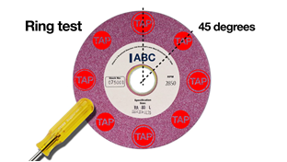image from Abrasive Wheel Safety Training | IIRSM Accredited | iHASCO
When the wheel is tapped at all four points, it should give off a clear metallic tone. The wheel is cracked if any of the four points sound dead. Do not use it.

