Emergency planning: Refuse collection
It is critical to know what to do in case of an emergency. There is no time to learn once the event is taking place. We will look at some key tips.
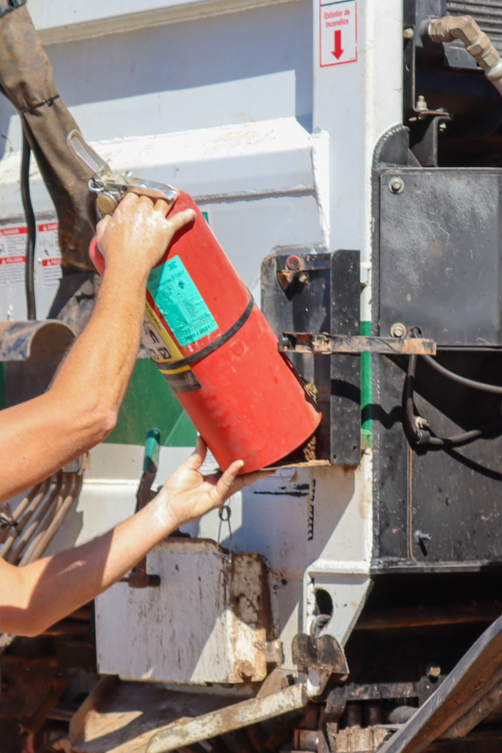
Emergency events to prepare for:
- Fire
- Severe weather
- Hazardous chemical release
- Threat of violence
Take the time to be familiar with the following:
- If the cab, under the hood or load catches on fire, pull over and contact a supervisor; notify them of the truck location and verify next steps
- If a fire starts in the load, follow direction from the supervisor
- Avoid driving into areas where heavy flooding or standing water is noted to have occurred
- If lightning is nearby, remain inside the vehicle and listen to local weather; proceed to a safe location outside of the lightning activity.
- When driving in high winds be alert to the potential effect of strong side winds on the vehicle, specifically at highway speeds; reduce speed and if necessary, pull over to side of the roadway, park in a safe location and activate emergency flashers
- Never try to outrun a tornado; get out of the vehicle and find shelter
- If unable to get to a safe structure, lie down in a ditch or low area; lie face down to stay protected from flying debris and cover the back of your head and neck with hands
- During ice and snow, bridges and overpasses freeze first, so always slow down and avoid sudden changes in speed or direction
- Keep speed steady and slow; using brakes cautiously
- If stuck in the snow, straighten the wheels, and accelerate slowly; avoid spinning the tires
- If a suspected hazardous chemical is present in or on the truck, pull over, exit the vehicle and notify a supervisor to verify next steps
- If met with aggression from human or animal stay in the vehicle, drive to a safe location and notify a supervisor
- Have a process to account for everyone in an emergency event
- Internal and external shelters should be identified
- Identify first responders
- Know what to expect regarding alarms and notifications for varying events
- Know the location of fire extinguishers and first aid kits
- Have emergency information posted and ready for emergency responders

Reviewing emergency response helps to keep all employees comfortable with emergency procedures and can make all the difference when a real emergency takes place.

