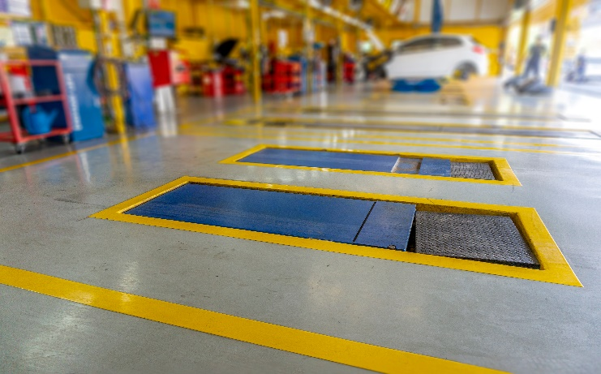
Auto shop open-pit safety talk
Having maintenance pits in auto repair shops for servicing vehicles is necessary; however, they are associated with many risks that can pose severe risks to employees' safety. Employees can be protected, and accidents can be prevented by understanding OSHA laws and regulations. Never get complacent during work tasks, especially around open pits and always know your surroundings.
It is important for employees in a service pit to follow basic safety precautions, which include:
- Employees must keep at least six feet clear of uncovered pits.
- The pit edges will have highly visible contrasting lines installed six feet away.
- Install warning signs and ensure employees follow them.
- Fuel tanks should not be drained from pits,
- When working under a vehicle, wear safety goggles or glasses.
- When not in use, each pit and trapdoor floor opening must be protected by a floor opening cover.
- Unless the cover is in place, the pit or trap opening shall be continuously tended by someone or shall be protected on all exposed sides by removable standard rails.
- Clean work areas near and in pits to ensure they are free of debris, tools, and parts
- Keep pits free of oil and grease.
- When working in a service pit, only use explosion-proof wiring, lighting, and power tools.
- Always keep ABC type dry chemical extinguisher in each service pit
- Prior to entering the pit, turn on the ventilation equipment for a few minutes.
  - Do not enter a pit that is in an area where a vehicle engine is running and is not properly exhausted.

