Safety Library Articles

- “Knowledge Center” has been changed to “Resources”

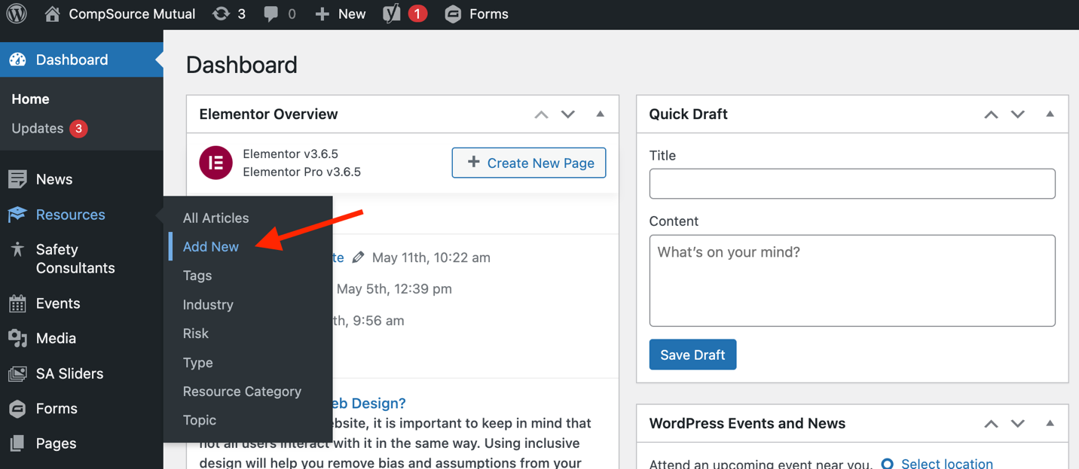

- There are only a few changes compared to the old system. Where to upload the file and checking the “Safety Library” box under “Resource Category” on the right. Everything else should be the same such as article title, content entry, and tagging your categories such as industry, risk, etc. NOTE: You do not have to add the file to the content area as a link anymore. Simply upload the file as show below and it will automatically create the button for download.

SEE SCREENSHOT ON NEXT PAGE
