# A screen shot of a computer Description automatically generatedpersonal protective equipment: solid waste management

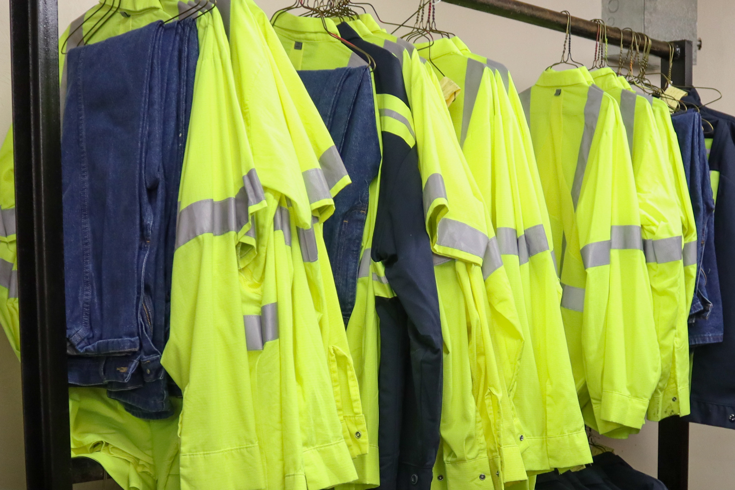Wearing the proper personal protective equipment (PPE) in your work environment helps minimize exposure to physical, environmental, chemical and biological hazards. Examples of typical workplace hazards include moving objects, working with solid waste that could have sharps or hazardous material exposures. PPE only works when it is right for the job and the environment.

*Necessary PPE Includes:*

**Clothing and footwear:**  Clothing to be worn should include long sleeved shirt with buttoned up collar and cuffs and pants. High visibility clothing should be worn by workers driving or riding in the truck.

Footwear should be a work boot style with a six-inch top or higher and slip resistant soles.

**Hand protection:** Gloves are a critical and simple way to guard from exposures and cuts. Use designated gloves provided by the employer only.

Fit is also an important consideration because if gloves are too large, they can impair dexterity of the hands or cause someone to lose grip, potentially causing an accident.

**Eye protection:** Using proper eye protection can help prevent injury and even blindness. Safety goggles or shields protect your eyes from chemicals, hazardous material, or flying fragments, dust, sand, dirt and other environmental hazards**** and should be worn when they exist.