# A screen shot of a computer Description automatically generatedCleaning and disinfecting: Meat processing

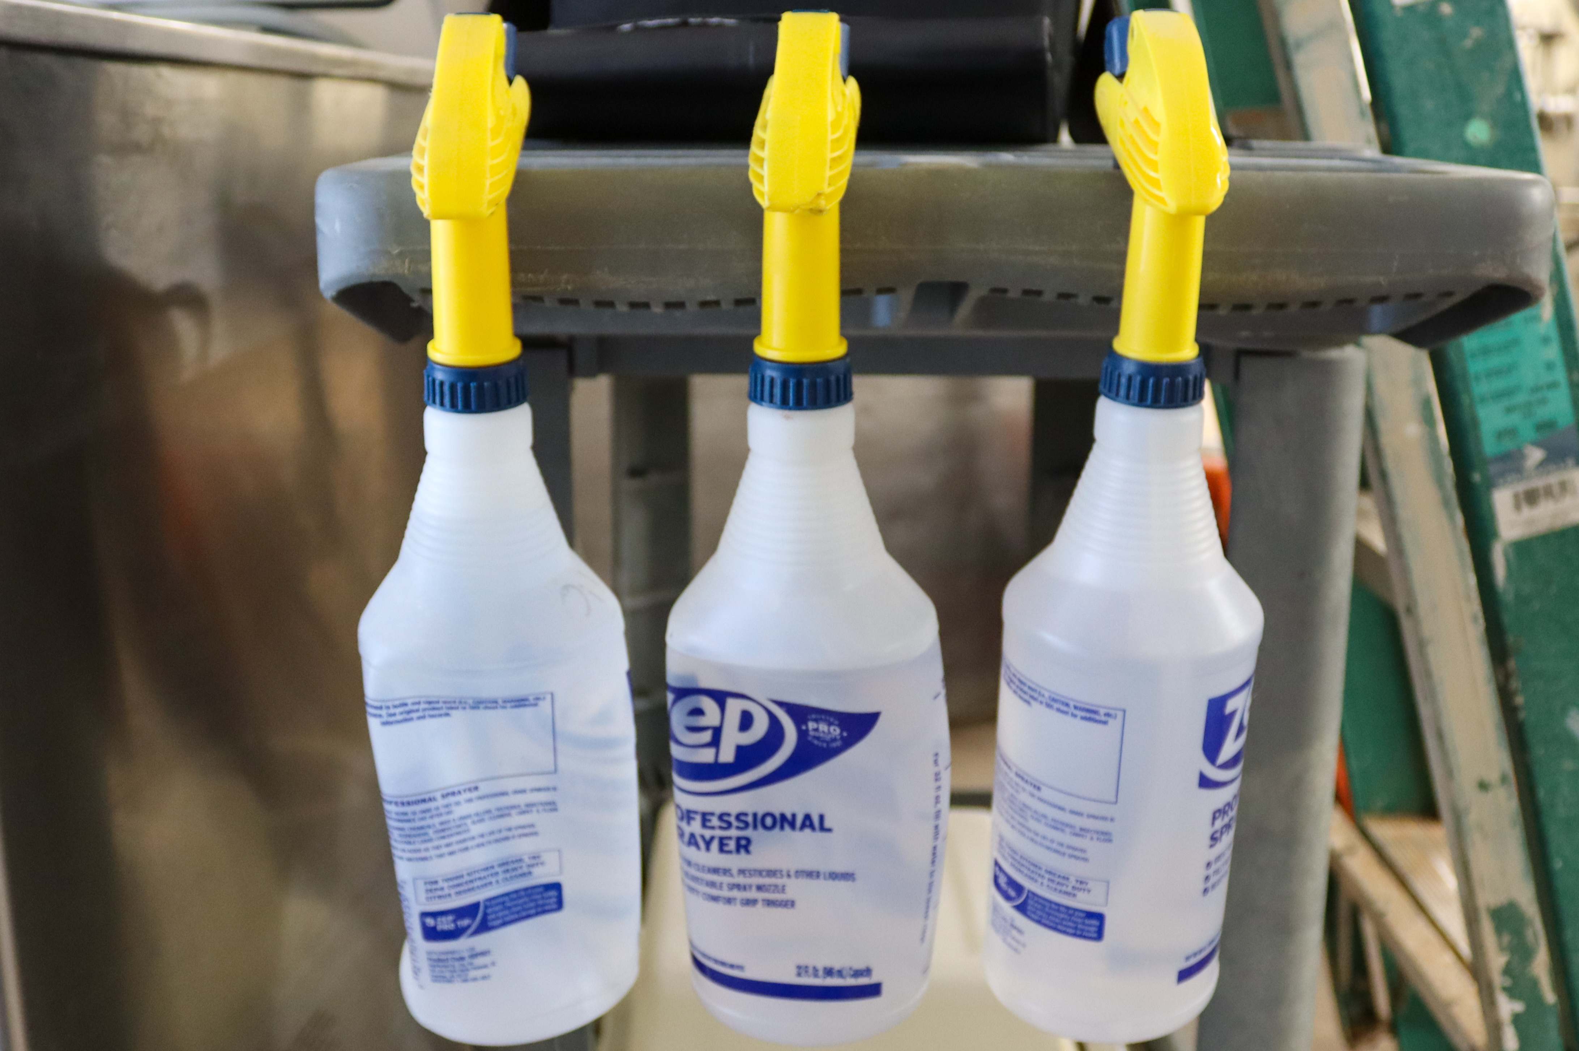With meat processing there are risks for bacterial and airborne disease which can cause illness. Cleaning and decontamination practices are vital in the success of this type of work.

*Tips to consider for handling, cleaning and disinfecting:*

* ****When handling raw meat ensure that disposable rubber gloves are being worn on hands or over cut resistant gloves to keep hands clean and dry.
* Wear long sleeves and pants to protect the rest of the body.
* Surfaces should be sanitized frequently throughout the day.
* Wash hands before each job task and before eating or drinking.
* 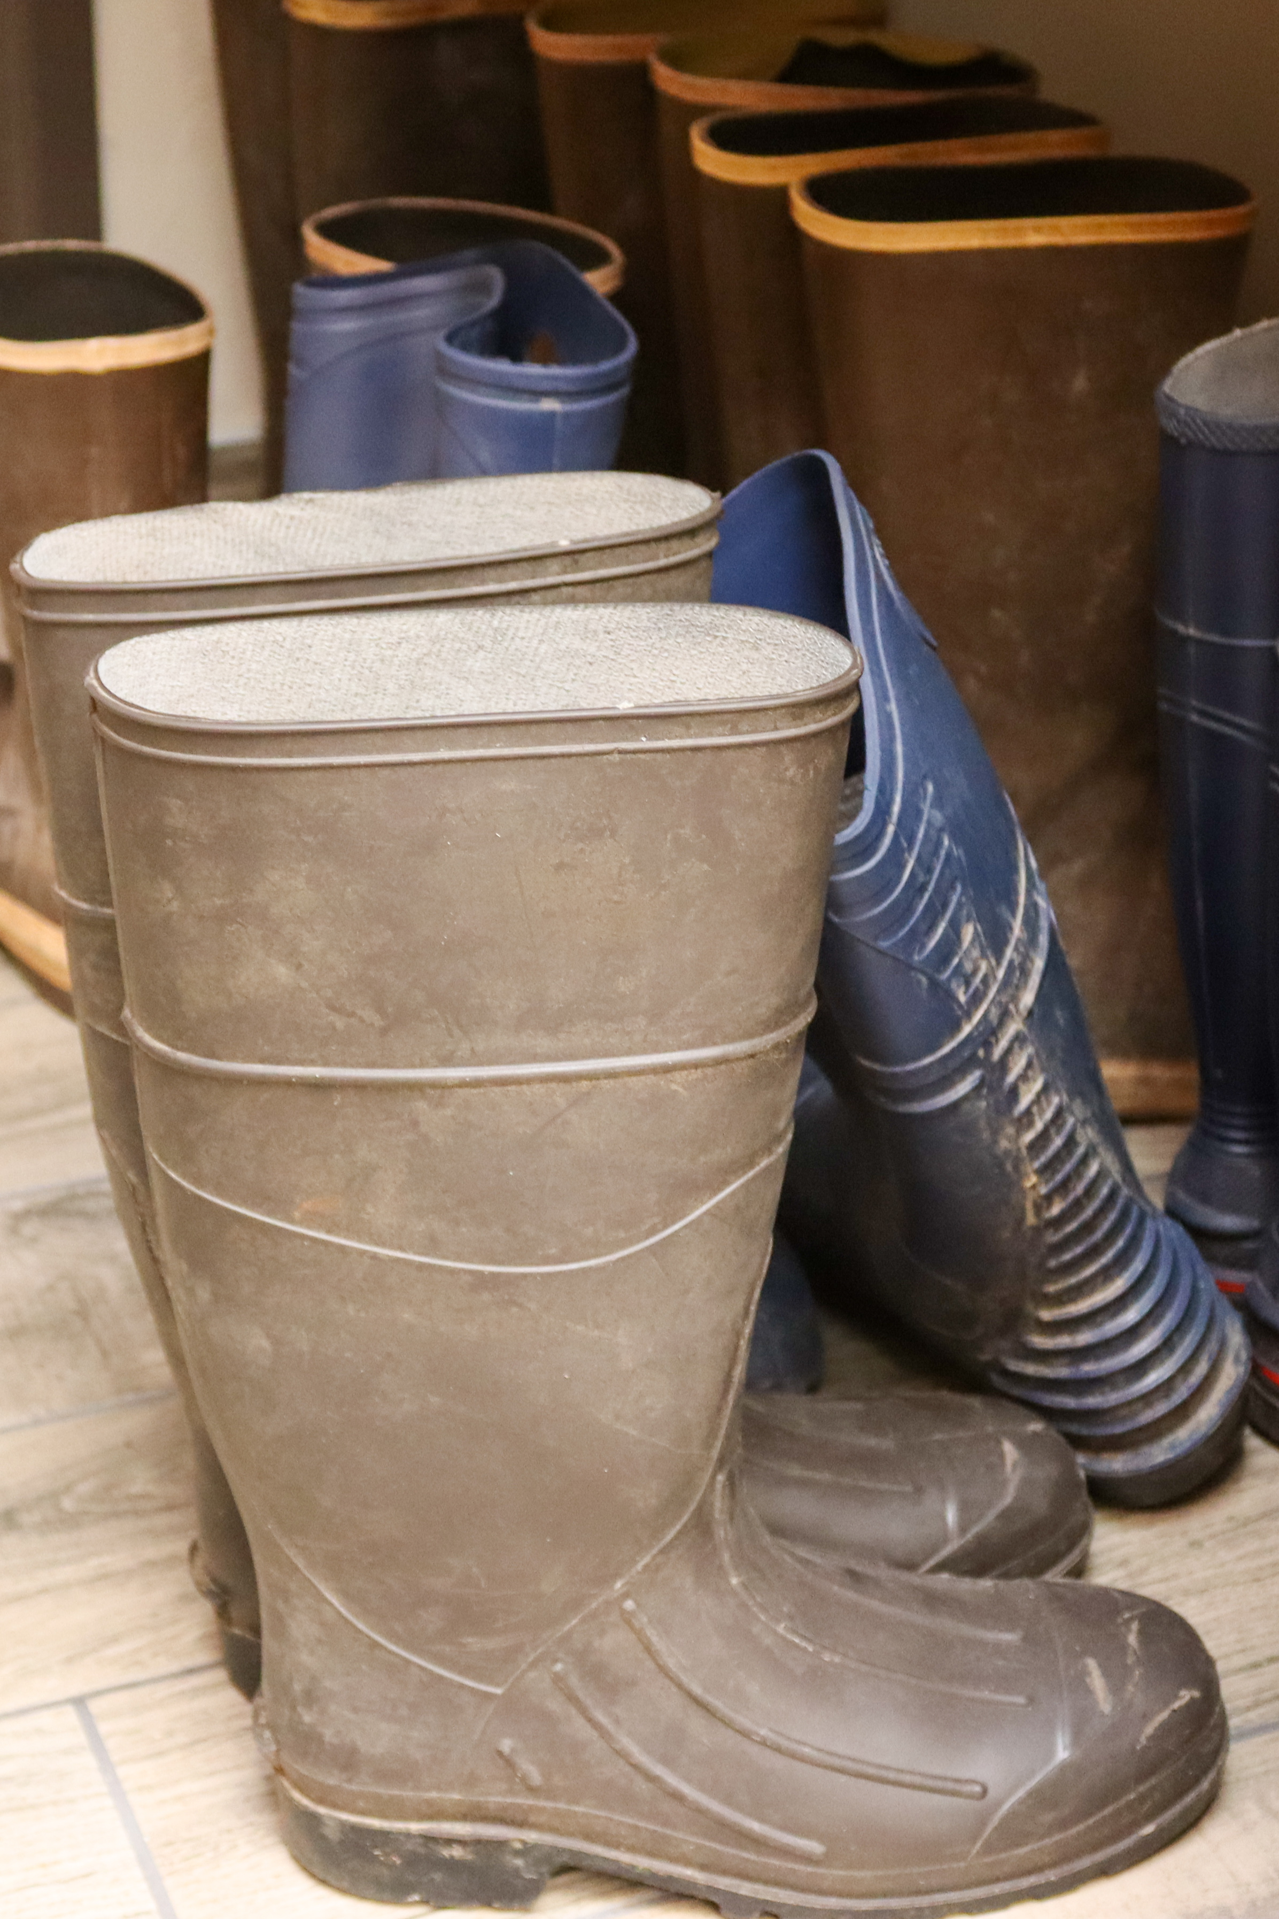Floors should be mopped each day and disinfected.
* Wear a protective mask if there is a risk of splashing liquid.
* All equipment should be washed and sanitized daily.
* Prior to cleaning and sanitizing equipment, ensure that it is powered down and locked out.
* Close toed shoes or rubber boots should be worn.

Know the specific cleaning expectations for your facility and follow them daily. It may prevent workers and others from getting sick.