# A screen shot of a computer Description automatically generatedCarbon dioxide and Carbon monoxide exposure

Both carbon dioxide (CO2) and carbon monoxide (CO) can both be present in medical cannabis operations. They can also both cause illness or death if employees are not trained properly and the atmosphere is not monitored correctly.

CO2 is used to enhance plant growth and plays a key role in the medical cannabis industry. However, when produced in high amounts it can become an asphyxiant. Best practices when working with CO2 include:

* 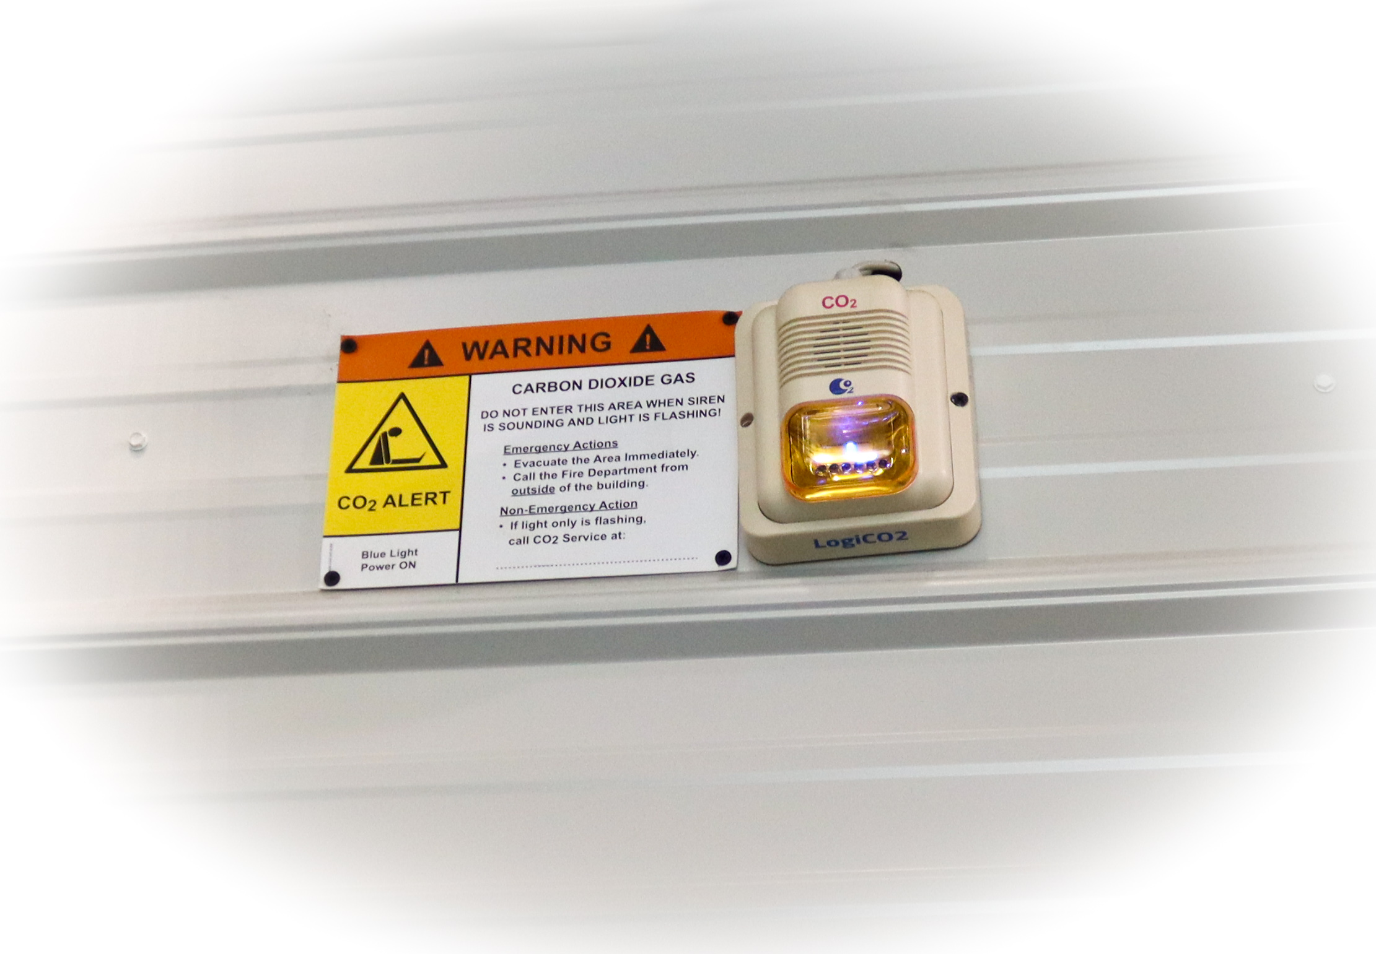Do a hazard assessment to see if CO2 is present and determine if and what personal protective equipment (PPE) may be necessary
* Monitoring devices should be present where there may be high concentrations
* If using dry ice to covert to CO2 take precautions when handling and storing as listed on product and safety data sheet (SDS)
* Ensure proper ventilation and engineering controls are in place to keep exposure to a safe limit

CO is a gas that is colorless and odorless making it undetectable without proper gas monitoring. It can quickly overtake someone causing severe injury and death. It is commonly produced when there is indoor equipment running such as a generator. In areas where there is the potential for CO exposure, monitors with alarms should be in place to alert employees if levels become too high. Below are some best practices when working around CO.

* Do a hazard assessment to see if CO is present and determine if and what personal protective equipment (PPE) may be necessary
* Use equipment that is not gas powered when indoors
* Ensure proper ventilation and engineering controls are in place to keep exposure to a safe limit
* Ensure there is a CO monitor with alarm
* Regularly maintain all indoor powered equipment

Ensure each employee is trained on the exposures to CO2 and CO. Make sure they are aware of the monitoring and alarm system and know what to do if it sounds. They should be aware of signs and symptoms of exposure and actions to be taken.