# A screen shot of a computer Description automatically generatedWeather hazards in roofing

Weather presents many hazards which can be compounded when working outdoors and on a roof. We will look at some of the most common weather-related dangers when it comes to roofing.

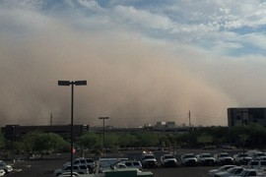

[This Photo](http://cronkitenewsonline.com/2012/11/state-agencies-collaborate-to-reduce-dust-storm-crashe/) by Unknown Author is licensed under [CC BY-SA](https://creativecommons.org/licenses/by-sa/3.0/)

*Potential hazards to address to address:*

* High winds can present many issues such as dust in eyes, instability while walking on the roof and creating dangerous situations regarding carrying large sheets of material that can act as a sail
* Inclement weather also poses a significant threat with lightning, tornadoes as well as moisture causing a slick surface

*Ways to prevent these hazards:*

* Stay up to date with weather forecasts and plan ahead
* Protect eyes, nose, and mouth from any blowing particles with appropriate personal protective equipment
* Ensure proper fall protection is in place and take extra caution with work done on edge of roof
* In high winds take extra care when moving large sheets of material by keeping them flat and utilizing team lifting
* Stop work if there is lighting in the area or a tornado warning and take cover

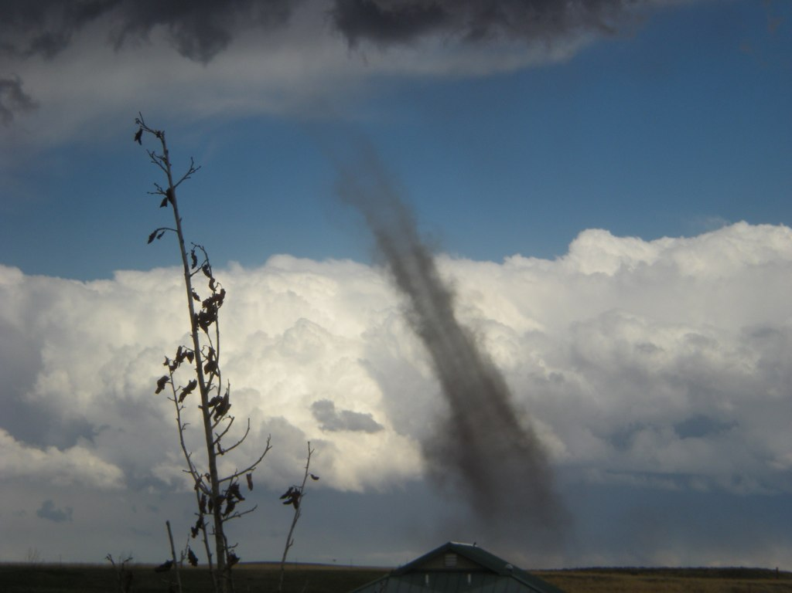

[This Photo](https://www.flickr.com/photos/noaanssl/5958357858) by Unknown Author is licensed under [CC BY-ND](https://creativecommons.org/licenses/by-nd/3.0/)

* Do not work on a wet roof and always wear non-slip footwear such as boots made specifically for roofing
* Windsocks can be used to determine wind direction and strength

[This Photo](https://www.flickr.com/photos/noaanssl/5958357858) by Unknown Author is licensed under [CC BY-ND](https://creativecommons.org/licenses/by-nd/3.0/)