# A screen shot of a computer Description automatically generatedtorching and welding

When doing torching or welding activities on a commercial roof, employees should have working knowledge about equipment, housekeeping practices, as well as fire prevention.



*Torching and welding equipment:*

* Ensure safety relief valves on cylinders remain unobstructed
* When not in use a safety plug should be in place for each cylinder valve
* Inspect all compressed cylinders for defects before use and always secure to prevent tipping
* Place torch and hand held welders on stand when not in use

[This Photo](https://ommoran.ca/2020/06/the-bc-strata-insurance-crisis/2/) by Unknown Author is licensed under [CC BY](https://creativecommons.org/licenses/by/3.0/)

* Inspect all hoses to check for any wear or tearing before use
* A regulator should be used any time torch or welding equipment is being used and all connectors should be leak tested before use
* Light torches with a spark lighter not with cigarette lighters or matches
* Do not leave torch connected to the cylinder when finished using
* Use walk behind welders when possible over handheld to reduce strain

*Fire prevention:*

* Know the expectations of the company emergency preparedness plan and follow them if a fire occurs
* All rooftop mechanical equipment should be disconnected and removed prior to these activities

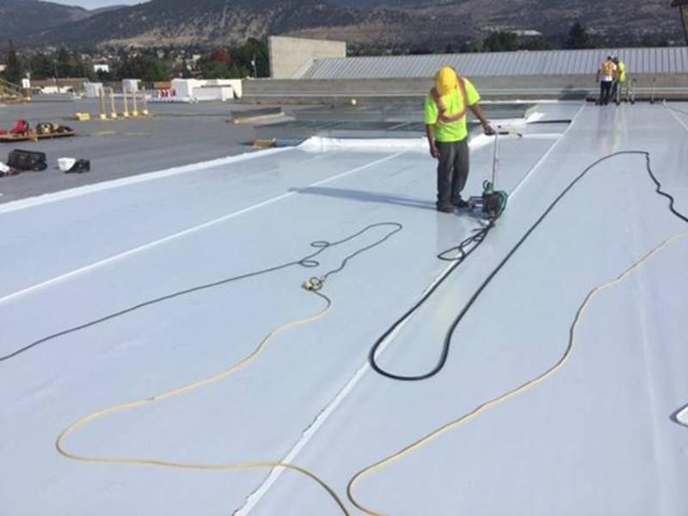

[This Photo](http://rpm.rcabc.org/index.php?title=File:TPO_project_(courtesy_Carlisle_Syntec).jpg) by Unknown Author is licensed under [CC BY-NC-ND](https://creativecommons.org/licenses/by-nc-nd/3.0/)

* A charged fire extinguisher should be within easy access during these activities
* Good housekeeping practices should be maintained on the jobsite with debris and flammables removed before beginning
* Natural gas service lines should be removed prior to torching; be alert to natural gas odor

[This Photo](http://rpm.rcabc.org/index.php?title=File:TPO_project_(courtesy_Carlisle_Syntec).jpg) by Unknown Author is licensed under [CC BY-NC-ND](https://creativecommons.org/licenses/by-nc-nd/3.0/)

* Shut down all rooftop mechanical units and remove filters as they pose a fire hazard
* Only torch areas that can be seen and never leave a torch lit unattended
* Gussets should be applied at internal and external corners to prevent flame penetration

*Protective clothing:*

* Long sleeve shirts and pants as well as work boots should be worn made from non-synthetic materials; clothing should be made of wool or cotton
* Wear leather work gloves with sleeves overlapping them
* Safety glasses should be worn as well