# A screen shot of a computer Description automatically generatedEmergency planning

It is critical to know what to do in case of an emergency. There is no time to learn once the event is taking place. We will look at some key tips.

*Emergency events to prepare for:*

* Fire
* Tornado
* Bomb threat
* Hazardous chemical release
* 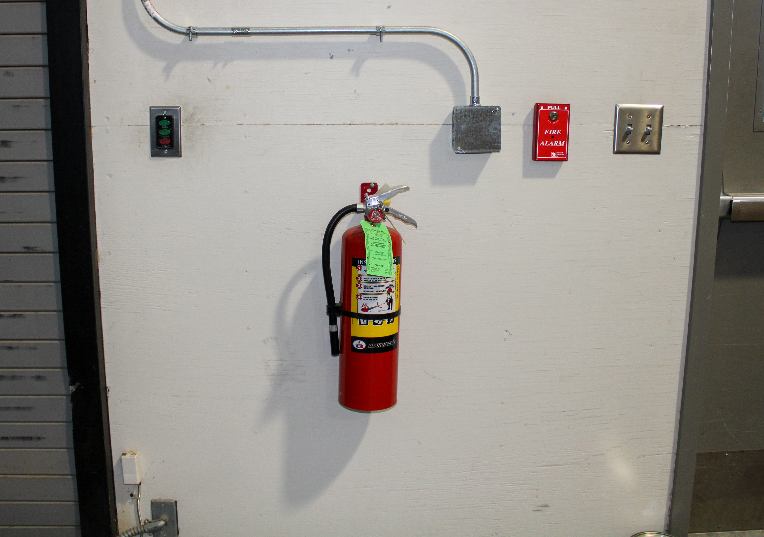Threat of violence

*Take the time to be familiar with the following:*

* Know the evacuation routes in the facility and which is nearest
* Huddle points should be known by all employees
* Have a process to account for everyone once relocated
* Internal and external shelters should be identified
* Identify first responders
* Know what to expect regarding alarm sounds for varying events
* Locate fire alarm activation points as well as extinguishers
* Locate first aid kits in facility
* Have emergency information posted and ready for emergency responders
* Have emergency gear such as lighting and radio available in shelter areas

Holding regular drills to keep all employees comfortable with emergency procedures makes all the difference when a real emergency takes place.

