# A screen shot of a computer Description automatically generateddollies

Material handling involves moving materials and stocking. This work involves pushing, pulling and lifting materials, sometimes with the help of dollies. Learning the following safe use practices of dollies will help prevent musculoskeletal disorders (MSDs), loss of mobility and time off the job:

* Before loading a dolly, check for any defects that could affect its operation or pose a hazard. Check for loose parts, torn wheels, greasy surfaces, air pressure on pneumatic tires, etc.
* Report potential hazards and have defective equipment repaired.
* Get help as needed, especially when tilting and un-tilting dollies.
* Lift with legs not the back, to shift the load into a travel position.
* Place heavy objects on bottom of load.
* Position load forward if necessary, for it to rest over the hand truck's axles.
* Do not stack items above eye level.
* Secure bulky, awkward or delicate objects to the hand truck.
* Get a firm grip.
* Keep back straight with knees bent and lean in the direction of travel.
* Push loads do not pull them.
* 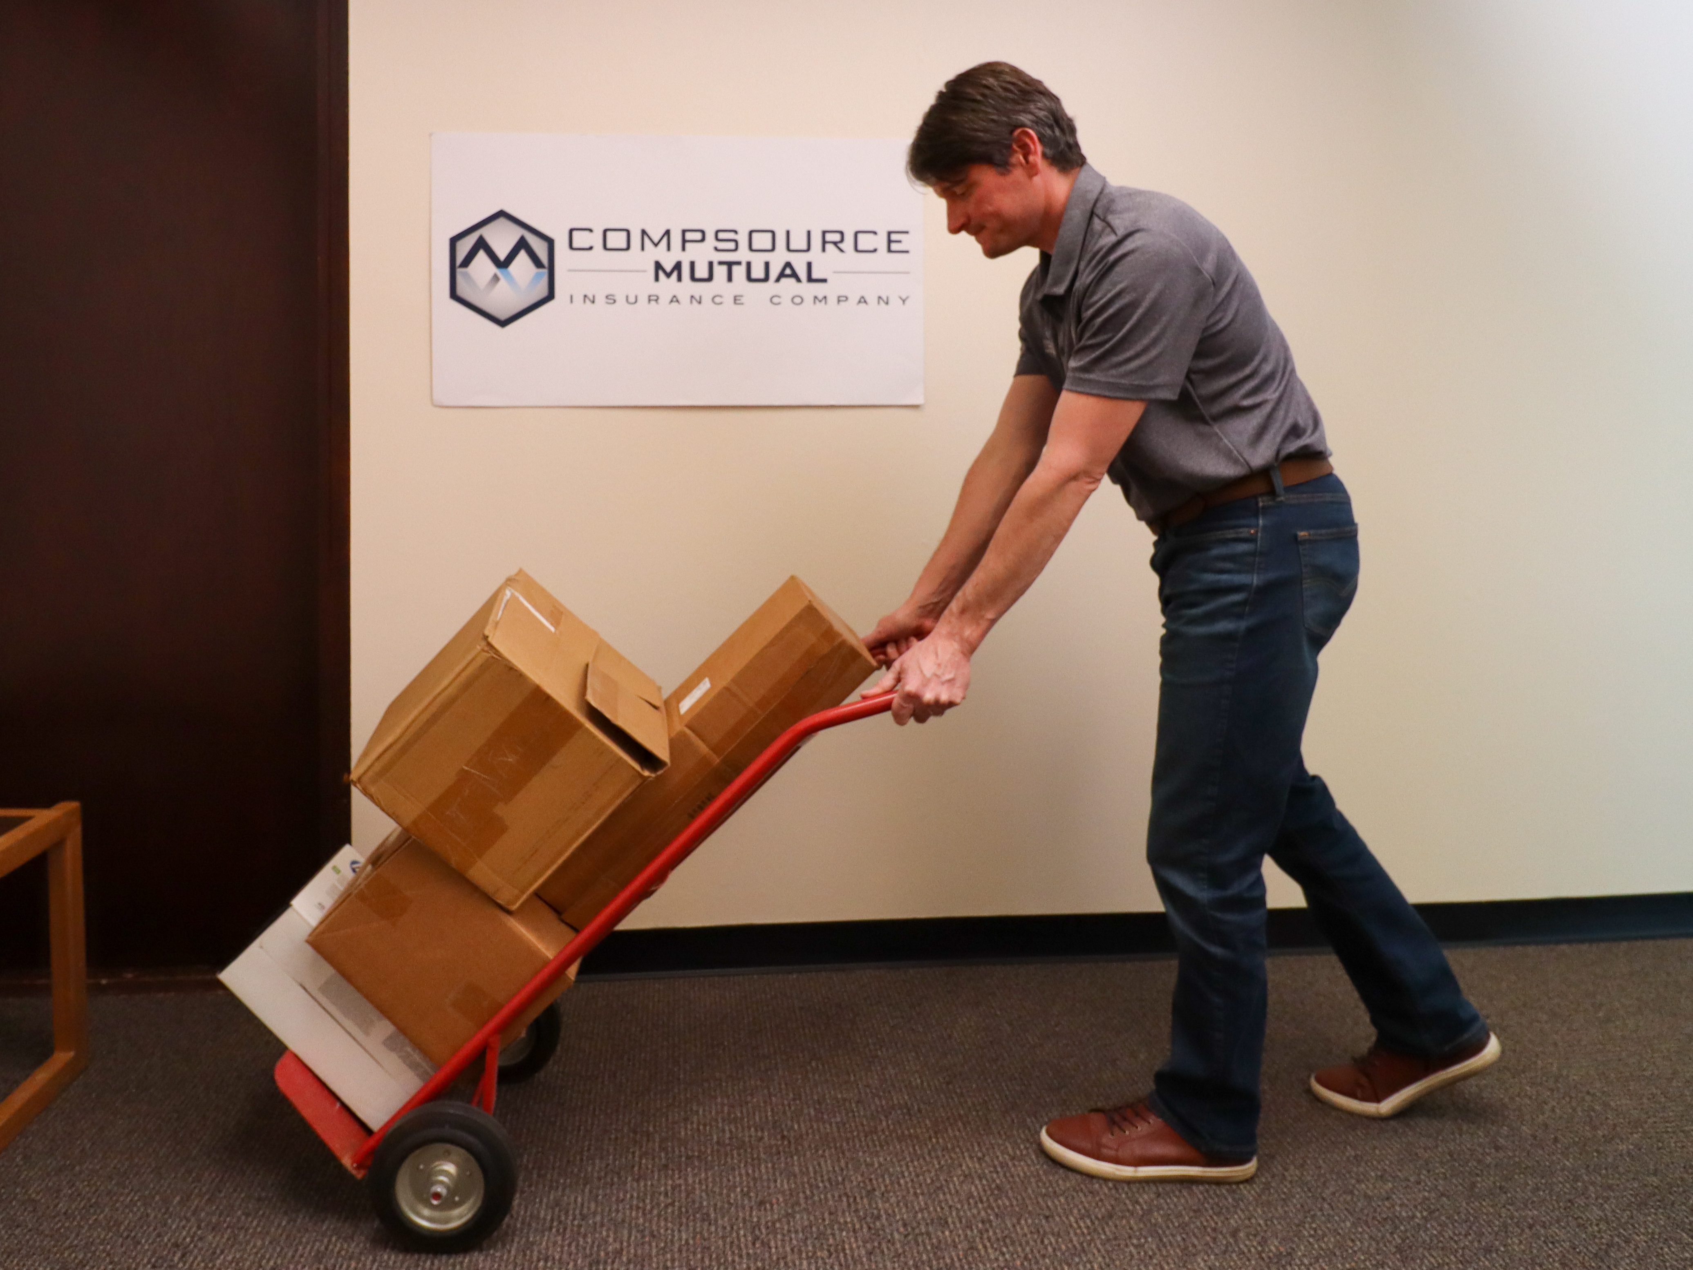Do not walk backwards unless necessary to maneuver in a tight space.
* To avoid getting pinned against something in a tight space, position the dolly or hand truck ahead.
* Develop good housekeeping practices to ensure floors are clean so there is minimal resistance.
* Wear shoes with good soles to maintain firm footing. 