# A screen shot of a computer Description automatically generatedDoing work overhead

The act of reaching overhead repeatedly can lead to injury. This is required at times when working from a ladder such as when installing gutters. There are steps that can be taken to eliminate these types of injuries.

*Tips to keep in mind:*

* Whenever possible keep work at eye level rather than above your head with neck tilted back
* If heavy tools must be used to do the job, ready the work area as much as possible and minimize the time spent working with the tool
* If the work requires twisting or getting into an awkward position to do, consider using a lift or scaffolding to gain better and more safe access to the area
* Stretching exercises should be done before overhead work begins and frequent breaks should be taken
* Vary work methods and positioning frequently
* Choose the best and most efficient tool for the job
* Take a break if feeling strain or fatigue
* If working from a ladder, keep the body’s center of gravity in the middle of the ladder not reaching too far

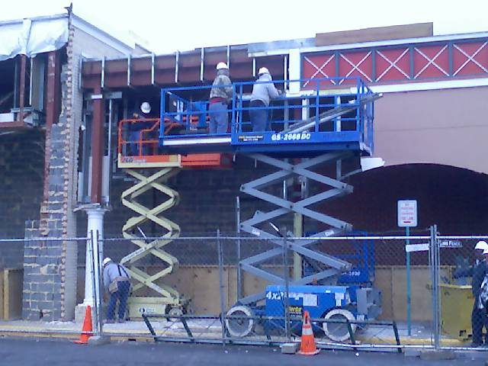

[This Photo](https://commons.wikimedia.org/wiki/File:Scissor_lifts.jpg) by Unknown Author is licensed under [CC BY-SA](https://creativecommons.org/licenses/by-sa/3.0/)



[This Photo](https://commons.wikimedia.org/wiki/File:Scissor_lifts.jpg) by Unknown Author is licensed under [CC BY-SA](https://creativecommons.org/licenses/by-sa/3.0/)