# A screen shot of a computer Description automatically generatedcommon slip, trip and fall hazards

Injuries happen from slips, trips and falls in every industry. No work is safe from this hazard. There are many reasons workers slip, trip and fall. We will look at some of the common areas of concern and what can be done to eliminate these common incidents from happening.

*Circumstances that may cause slips, trips or falls:*

* Floors that are wet or greasy
* Newly polished or waxed flooring
* Poor housekeeping such as cords or other material and equipment in the walkway
* 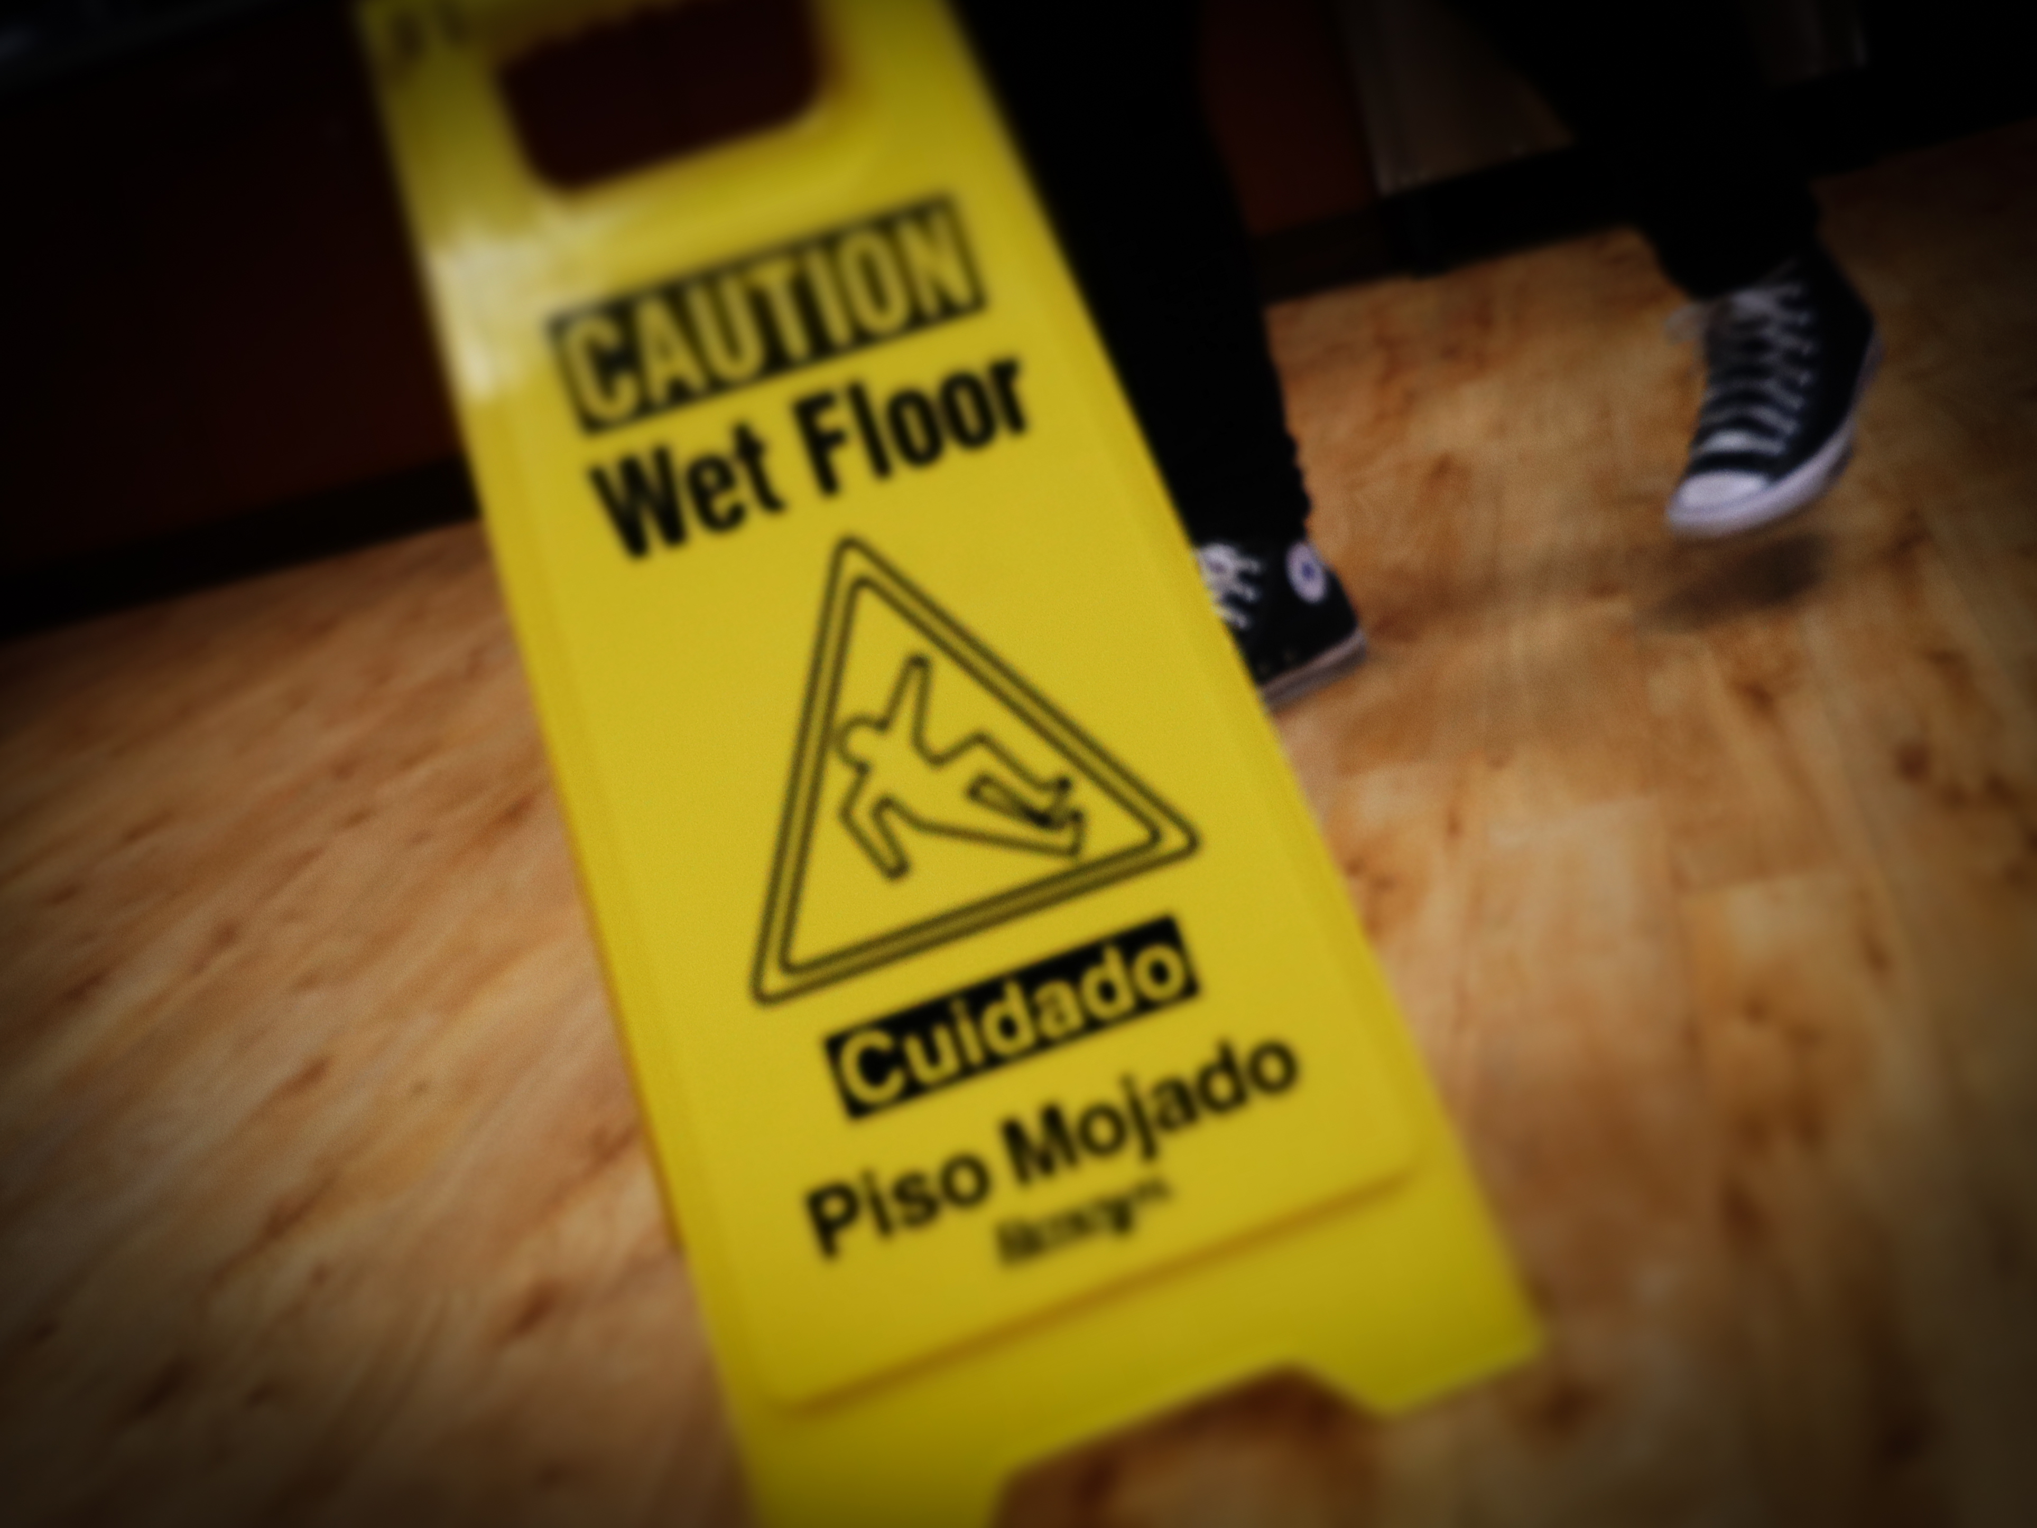Open drawers that can cause a trip hazard
* Level changes that are not marked with level and color change
* Drop offs such as loading docks that are improperly guarded
* Debris left laying around on the ground
* Broken floor tiles or curled rugs or carpet
* Having improper footwear on such as open toed shoes
* Missing handrails for steps and stairs
* Ladders or steps that are damaged, wet, or greasy
* Weather related hazards such as rain, snow and ice

*Ways to prevent these hazards:*

* Ensure floors are swept and mopped regularly with wet floor signs placed until the area is dry. Wax and polish floors during off time when possible to give ample time for drying and setting as well as placing signs to let employees know. Employees are required to wear closed toe, flat footwear with good gripping sole. Any flooring that is in poor condition should be reported and replaced immediately.
* Have a scheduled housekeeping plan in place to keep floors and walkways tidy.
* Keep all drawers and cabinet doors closed when not in use.
* Mark all level changes with a bright color such as an unexpected drop in the floor or areas of curb that are used for entering the building.
* Ensure steps, stairs, docks and other areas with a drop off have adequate handrail or other means of fall protection in place.
* Ladders should be clean, dry and inspected properly before use and discarded if damaged.
* Procedures should be in place regarding weather related hazards such as placing ice melt, wet floor signs and extra matting at entries.