# A screen shot of a computer Description automatically generatedchemical handling

Chemicals can be found on every commercial roofing jobsite. Examples of common chemicals that may be encountered include gasoline, sealants, cleaners, etc.

*Chemical exposure can occur 4 different ways:*

* Inhalation: breathing in dusts, mists and vapors
* Ingestion: eating contaminated food (food that has been exposed to airborne contaminants)
* Absorption: skin contact with a chemical
* Injection: forcing an agent into the body through a needle or high-pressure device

*How to protect against chemical hazards:*

* Reading container labels, safety data sheets (SDSs) and safe-work instructions before handling a chemical.
* Using specified personal protective equipment (PPE) that may include chemical-splash goggles, a respirator, safety gloves, apron, steel-toed shoes or safety glasses with side shields.
* Inspect all PPE before use. Look for defects in the equipment such as cracks, missing parts, rips, etc.
* Know where the safety showers and eye wash stations are located and how to use them.
* Wash hands before eating, especially after handling chemicals.
* 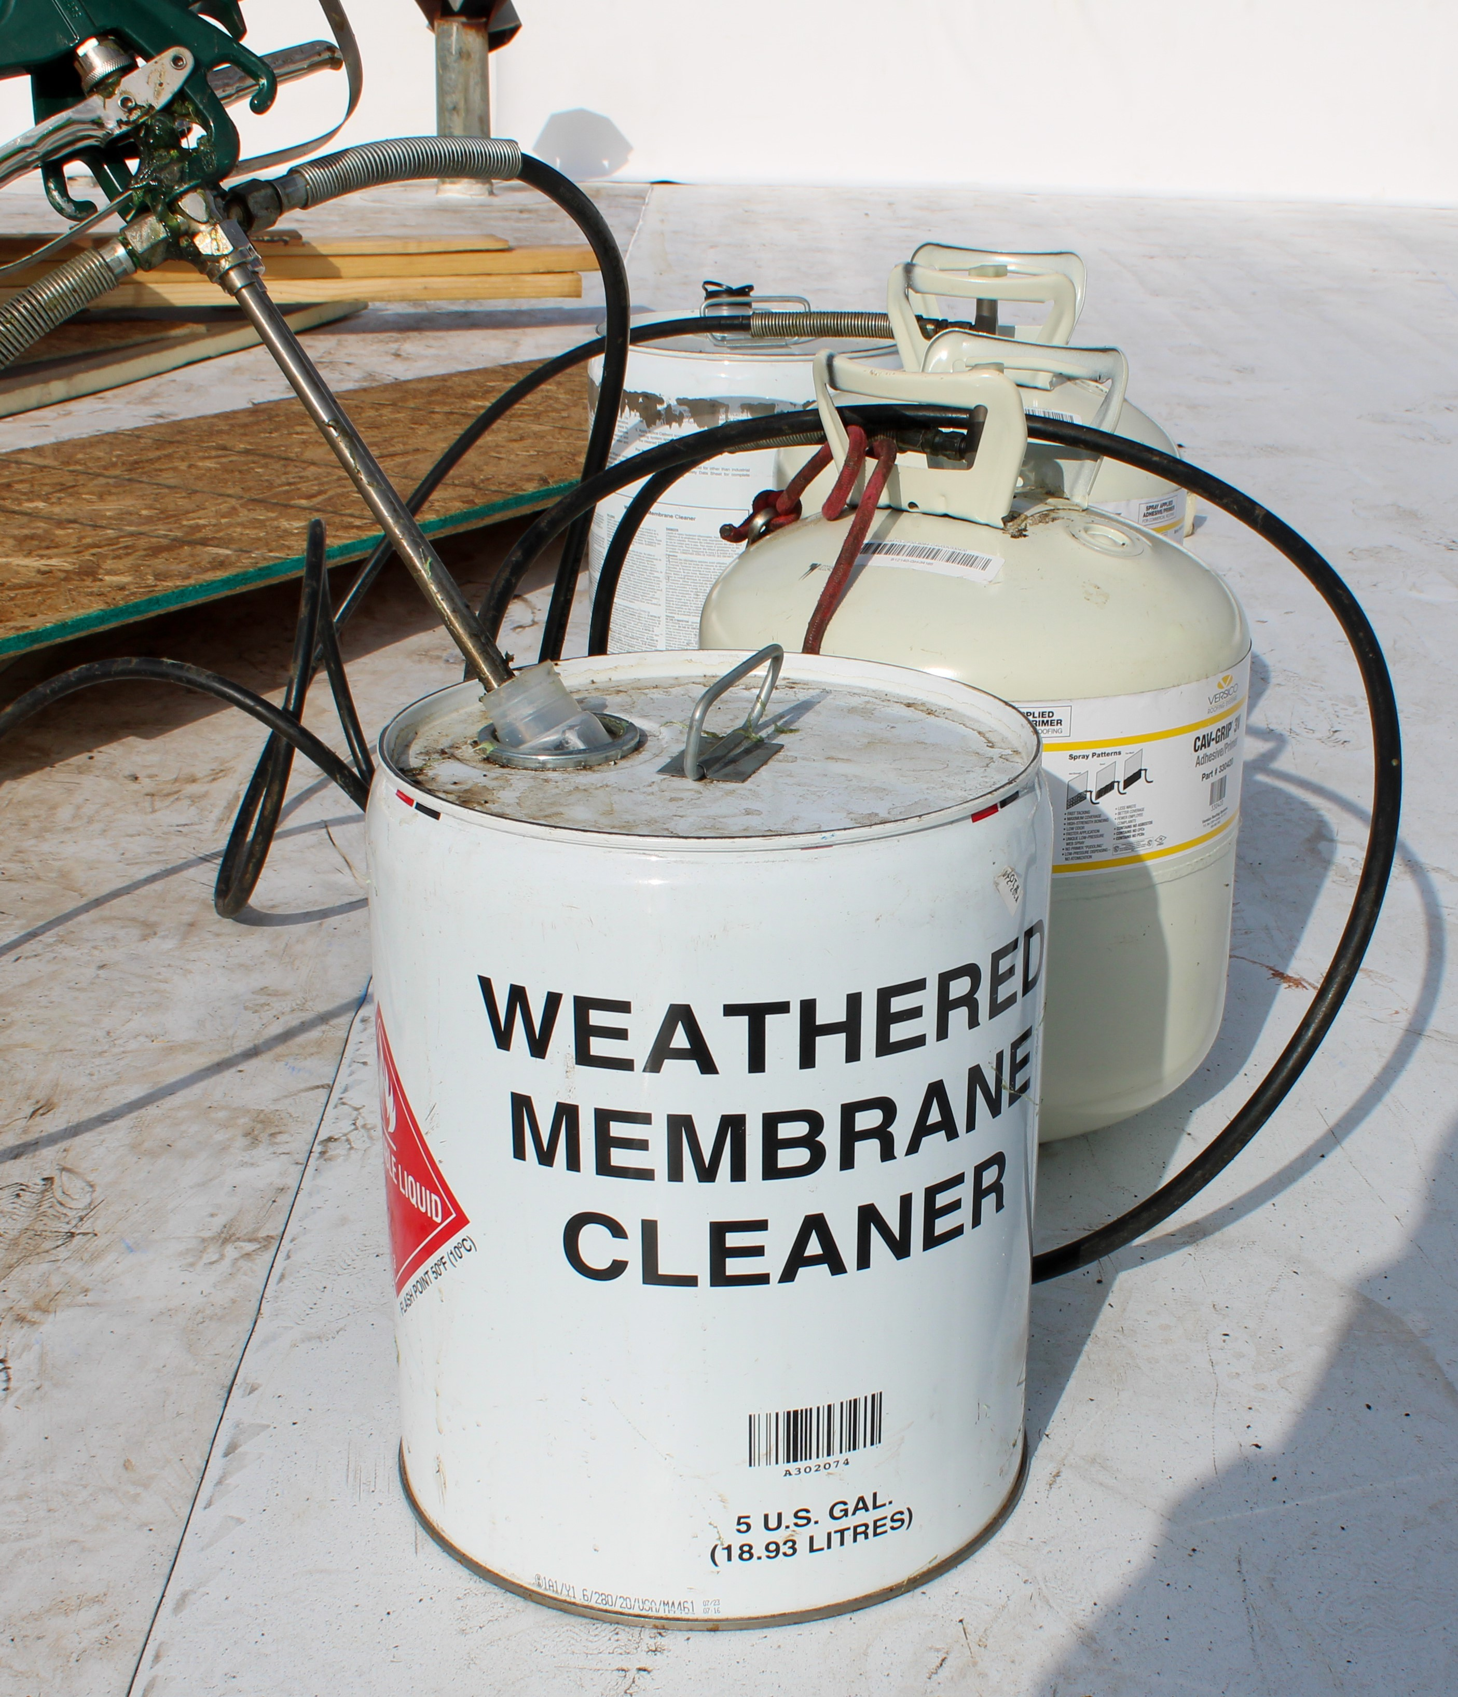Leave contaminated clothing at work to eliminate the possibility of exposing others to the hazards.

