# A screen shot of a computer Description automatically generatedTIRE and wheel safety

There are many reasons to keep an eye on truck tires. It can increase the lifespan with preventative care as well as increase fuel economy. However, most importantly it can prevent blowouts, ensure you have proper traction while moving along the road and overall keep the driver safe. Truck tire and wheels should be inspected daily before getting on the road.

*Areas to look at during pre-trip inspection:*

* *Tire pressure*- Know your company’s tire pressure requirements and check them regularly to ensure they are up to standard. Only operate a vehicle if the tires are properly inflated. If tires have any issue holding the correct pressure report them immediately. Tires must be inflated or repaired in a tire cage.
* *Tire tread*- Required tread depth should be checked daily during the pre-trip inspection. Low tread depth can cause a blowout if debris or potholes are hit. Uneven tread can be a sign of inaccurate air pressure.
* *Tire condition*- Ensure that no sidewall damage is occurring such as bulging, cuts, separation etc. Look for leaks daily or sign of extensive wear as well as anything unusual.
* 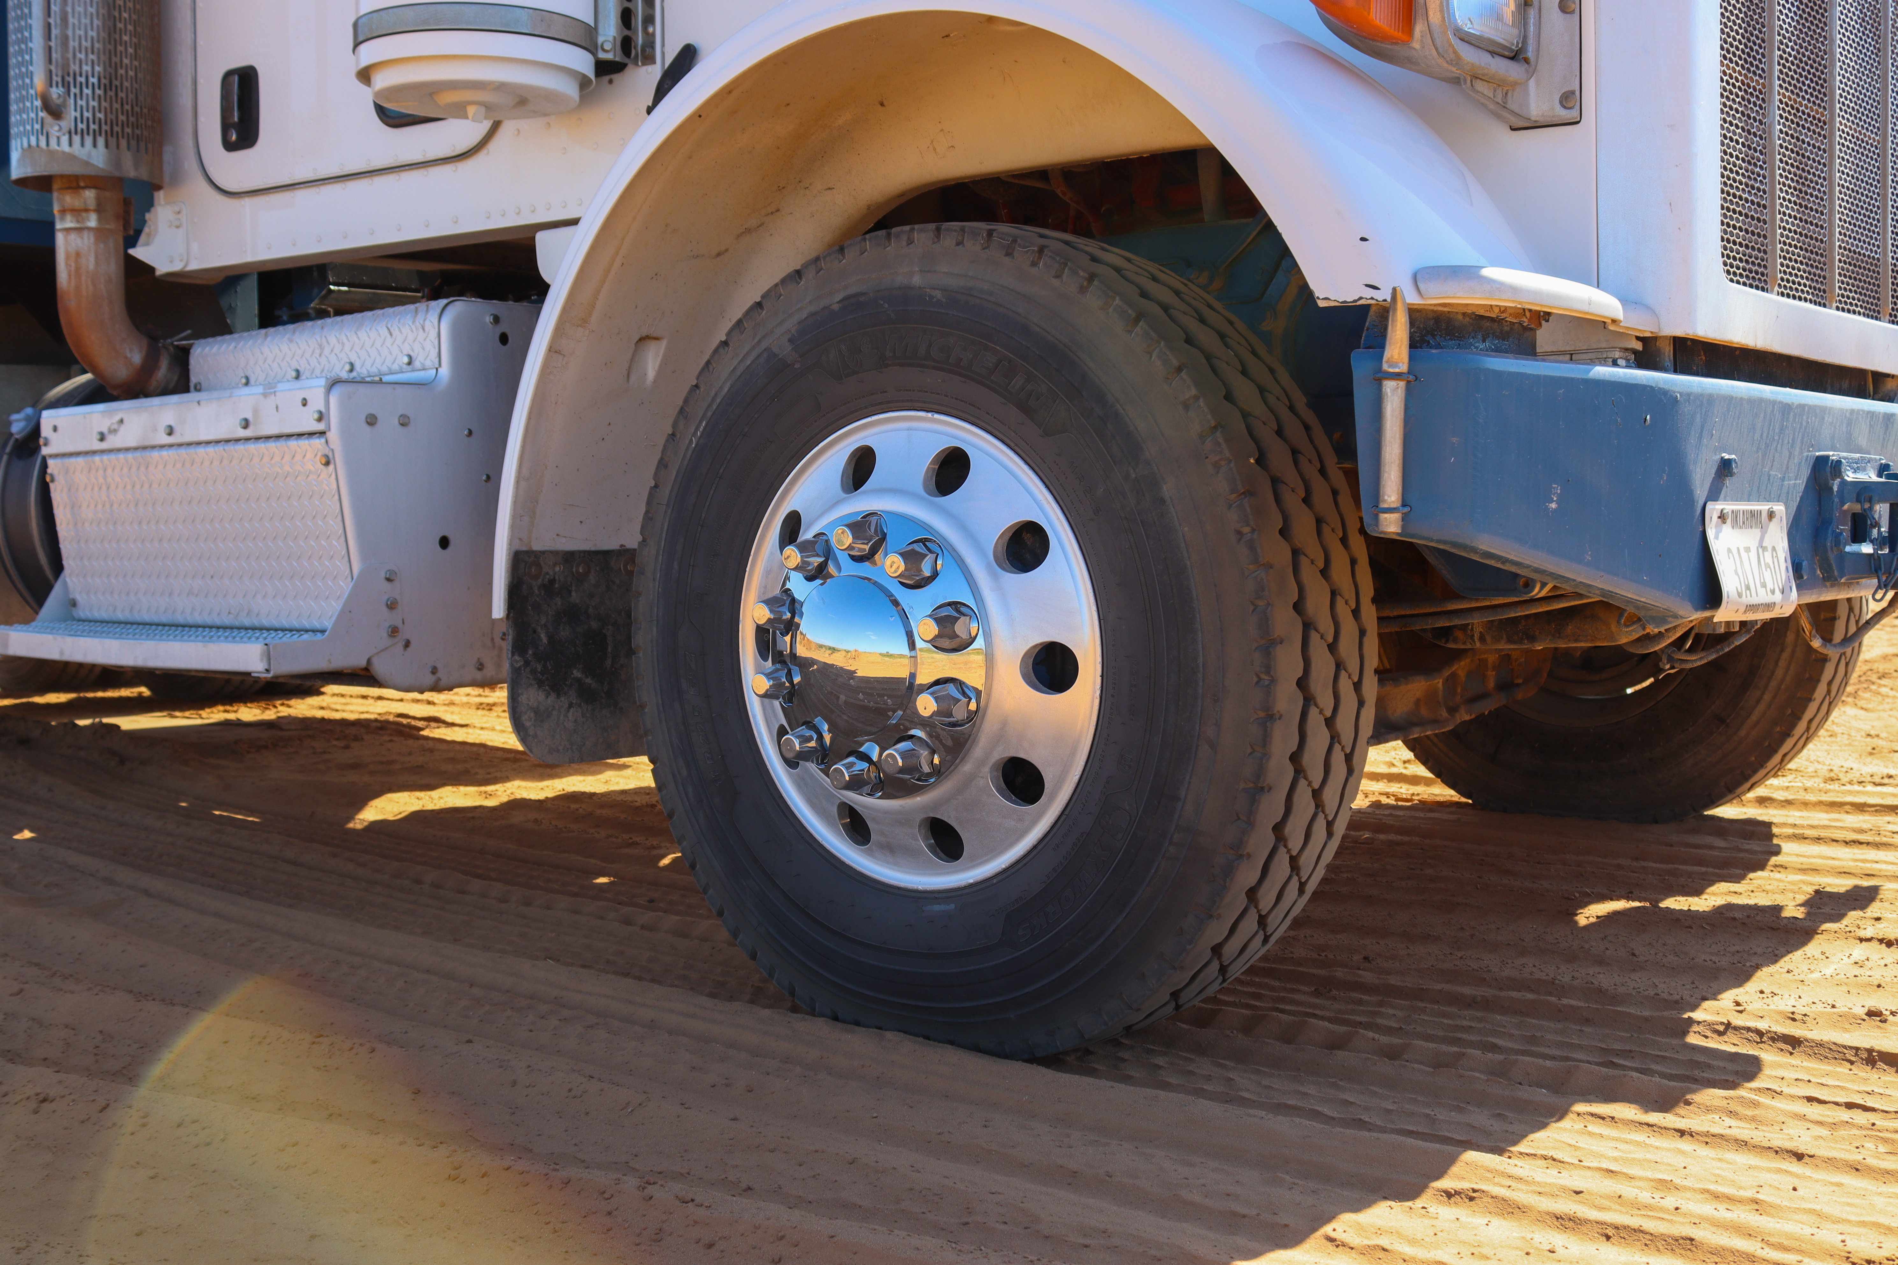Wheel inspection- Check lugs for tightness. Missing or damaged valve caps should be replaced immediately. Ensure there are no wheel seal issues and look for any defects.

In addition to inspecting these areas tires and wheels should never be used as a step to climb as this could contribute to a fall. If a large hole is hit or any debris in the road, pull over and inspect tires again. Don’t assume all is okay.

# 

