INJURIES

If you are injured on this assignment, contact (Company Name) immediately. If your injury requires emergency treatment, follow instructions for medical emergency treatment.

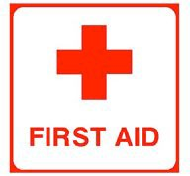
NOTE: Advise the medical care facility that you are an employee of (Company Name).

DRESS CODE
 | Required | Permitted | NOT  Allowed
Jeans
Casual dress pants
Shorts
Jewelry
T-Shirts
Tank Tops
Dresses/Skirts
Steel-Toe Boots
Open-Toe Shoes
Tennis Shoes

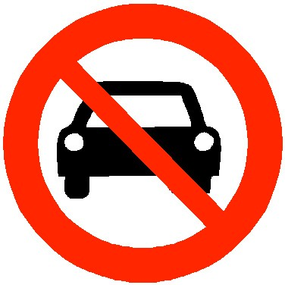

Absolutely NO DRIVING of any vehicle without expressed written permission from (Company Name).

Please sign below acknowledging that you have reviewed this orientation brochure, understand and accept the requirements of the assignment.

Assignment:
Location:
Time:
Report to:
Special Instructions:

Print Name

Signature Date

Signature (Company Recruiter) Date

(Insert Company Name)

Phone # Here

After hours / Emergency: 24/hr Phone # Here

Insert Web Page Here

Congratulations on your new career opportunity with (Company Name).

ATTENDANCE STANDARDS
Punctuality, reliability, and attendance are equally important, as the ability to perform the job functions, on this assignment. During this assignment, you are expected to be
at work on time every day and work the entire shift. If any of the following situations occur, notify your supervisor and (Company Name) immediately:

- If you are going to be late for your assignment

- If an emergency situation prevents you from reporting to work

- If you need to take time off during your scheduled work hours (two day notice is required)

- If you are unable to complete your assigned hours for the day

- If you intend to end your assignment early for any reason; please give as much notice as possible. Be aware that advance notice of one business day is required; if you want to be considered for future assignments with (Company Name).

EMAIL, TEXT, FACEBOOK, etc. ARE NOT SUFFICIENT FORMS OF NOTIFICATION.

Timecards are due in the company office Monday morning. You are welcome to call our main on Tuesday morning and verify your time.

PAYCHECKS
You are paid weekly (Thursday) by direct deposit, pay card or check. If there is ever an issue with your pay, call the office during business hours. Give your name, where you are working, and the week-ending date of the pay in
question. It will be resolved as quickly as possible. We appreciate the hard work you do and will make every effort to ensure your pay is on time and correct.

SAFETY

SAFETY GLASSES, EARPLUGS, AND SAFETY VESTS MAY BE REQUIRED. ASK YOUR SUPERVISOR FOR CLARIFICATION.

- Follow all safety protocols, particularly those regarding the operation of equipment.

- Obtain instructions before trying to operate unfamiliar equipment.

- Immediately report any unsafe conditions you notice to your assignment supervisor.

- Locate the aisles, stairways and exits you should use during an emergency.

- When opening boxes, use the proper cutter. Cut away from your body. Store the cutter safely.

- Lift correctly—bend your knees, hold the object close to your body and lift with your legs. When moving the object, turn your whole body. Do not twist your spine. Get help when you need it.

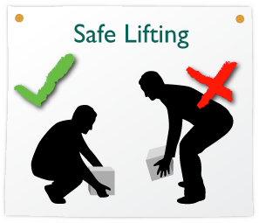
- You may be expected to stand for long periods.

- You may be required to lift 25-50 lbs.

- You may be required to lift 51-100 lbs with assistance.

- Occasional or frequent bending, squatting, stooping, kneeling, pushing, pulling, reaching, and walking may be required.

- Frequent repetitive motion may be required.

- The above statements are intended to describe the general nature of the physical requirements and working conditions for some assignments.

If you have any safety concerns or questions, please inform (Company Name) immediately.
PERSONAL BELONGINGS
Please do not bring valuable items to work. Any personal items should be kept locked in your car or left at home. (Company Name) assumes no liability for your personal items and valuables.

TELEPHONE CALLS
All incoming phone calls must go through the main office. We will relay emergency phone messages to you through your supervisor.

Do not use business phones for making personal calls. Calls may be placed during your lunch and break periods in a designated area. Cell phones are not allowed on the job site and are only to be used on personal time.

DRUG-FREE WORKPLACE
(Company Name) abides by the Drug-Free Workplace Act. We believe a drug-free environment is vital to the safety and well-being of our employees and customers.

TOBACCO POLICY
Unless otherwise stated, this is a tobacco free assignment. If violated, this is grounds for termination.

TO OUR EMPLOYEES
Thank you for accepting this assignment. As a (Company Name) employee, you represent (Company Name) to our client. We are counting on you to be thorough, efficient and professional; to complete assigned tasks and take pride in your work as part of a highly motivated and capable team.

Please contact us if you have any questions, problems or concerns related to your work. If the work you are doing on this assignment is
different from the original job offer, please contact our office immediately.

