# A screen shot of a computer Description automatically generatedRouter safety talk

1. Use push blocks to position your hands a safe distance from the bit.

2. Large-diameter bits are for use only in a router table. Using bits over 1 in. dia. in a handheld router can easily cause you to lose control of the tool.

3. Always wear eye and hearing protection.

4. Take light cuts. Heavy cuts invite kickback. If necessary, move the fence closer to the bit or switch to a larger guide bearing.

5. Use a featherboard to support the workpiece against the router table or fence.

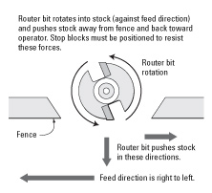6. Never climb-cut. Always feed the stock from right to left. (see illustration at right)

7. Avoid shaping small stock. Instead, shape a larger piece and reduce it in size afterwards. If you must shape a small piece, build an appropriate jig or secure the work within the jaws of a wooden handscrew clamp.

8. Always use a guard. If the fence didn’t come with a guard, purchase an aftermarket guard or devise one of your own.

9. Never start the router with the bit in contact with the stock.

10. Don’t force the bit or overload the router.

11. Secure the motor in the base before starting the router.

12. Do not bottom out the bit in the collet or partially insert the bit. Instead, completely insert the bit, and then back off approximately 1/16 in.

