# A screen shot of a computer Description automatically generatedtrucking ergonomics

Driving a delivery vehicle or truck for long periods of time or even for short spurts all day can be hard on the body. This obviously comes on top of other difficult tasks such as securing, loading, and unloading the truck. There are several things that can be done to lessen the risk for injury.

*Seat Positioning:*

* Take time to get familiar with seat adjustments and ensure they are positioned correctly
* Adjust the seat until there is a comfortable reach to the pedals and steering wheel; arms should be at a slight angle
* Ensure knees are not in higher alignment than hips
* The drivers entire back should be able to comfortably rest against the seat for support
* The front of the seat should not press into the back of the knee
* Thighs should be completely supported by the seat
* Ensure the seat and the suspension beneath are in good condition
* Provide lumbar support either through the chair controls or with an additional cushion

*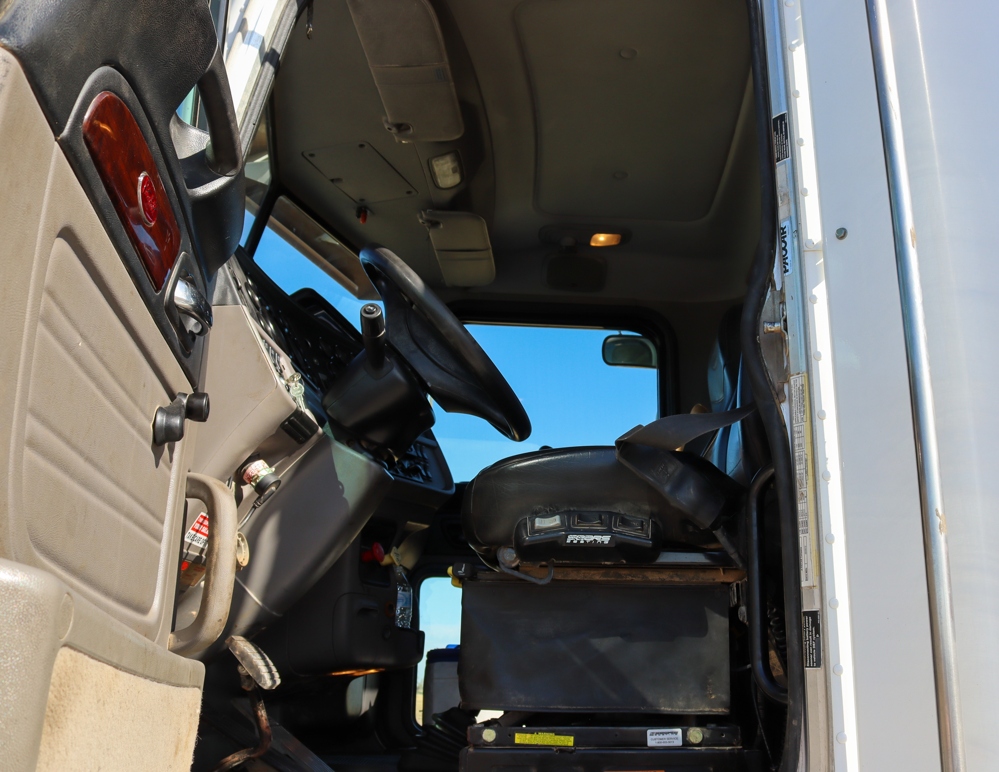Tips for Driving Comfortably:*

* Make slight changes in hand positioning often and be mindful that grip is not too tight
* Make minor adjustments in the sitting position every 30 minutes to relieve pressure to any one area
* If needed add an extra pad or cushion for additional support
* Adjust mirrors to avoid leaning to see
* Have all regularly used items within direct reach before departing

*After the drive:*

* Give the body time to adjust before unloading product; get out, walk around, complete other tasks such as paperwork or product inspection
* Take care to exit the vehicle safely using the provided grab bars and steps

