# A screen shot of a computer Description automatically generatedwelding safety

The potential for injury while welding is significant and can include burns, exposure to fumes and light and  
heat radiation.

*While not an exhaustive list, the tips below help to reduce the potential for a workplace  
accident when welding:*

• Inspect all equipment prior to use (torches, electrical components, regulators, etc.)  
• Flammable and combustible materials should not be stored within 50 feet of welding area  
• Sufficient local exhaust and ventilation should be provided to remove welding and hot work fumes  
• When ventilation is insufficient to control the respiratory hazard, proper respiratory protection should be used  
• Welding screens are used to protect nearby workers from the flash glare of welding operations or from sparks generated from cutting operations  
• Firefighting equipment should be readily available nearby

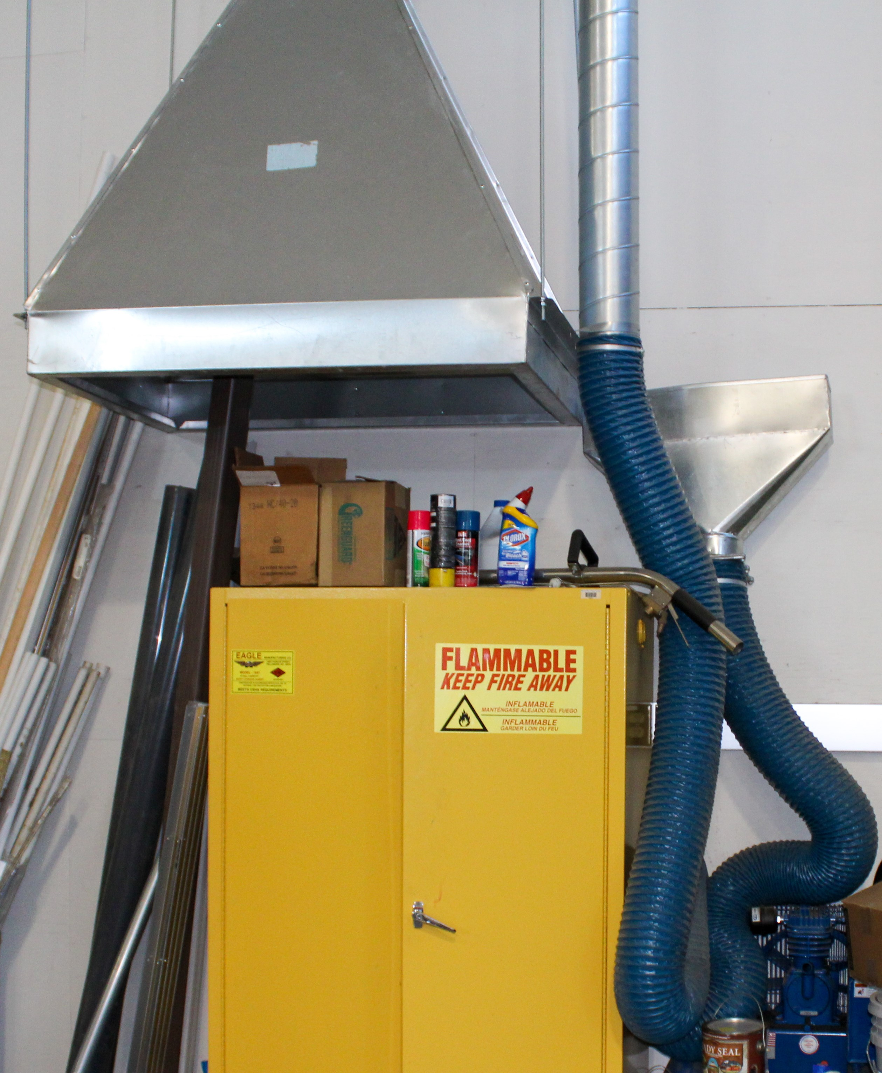*Personal protective equipment should include:*

• Welding hood and gloves  
• Clothing made from wool or wool blends rather than cotton  
• Leather cape, jacket or apron  
• Dark clothing to help reduce reflected light

