# A screen shot of a computer Description automatically generatedpowerline hazards for dump trucks

Powerline contact is a hazard to be mindful of when driving a dump truck. It is critical to know best practices around loading and unloading trucks safely.

*Types of electrical hazards:*

* 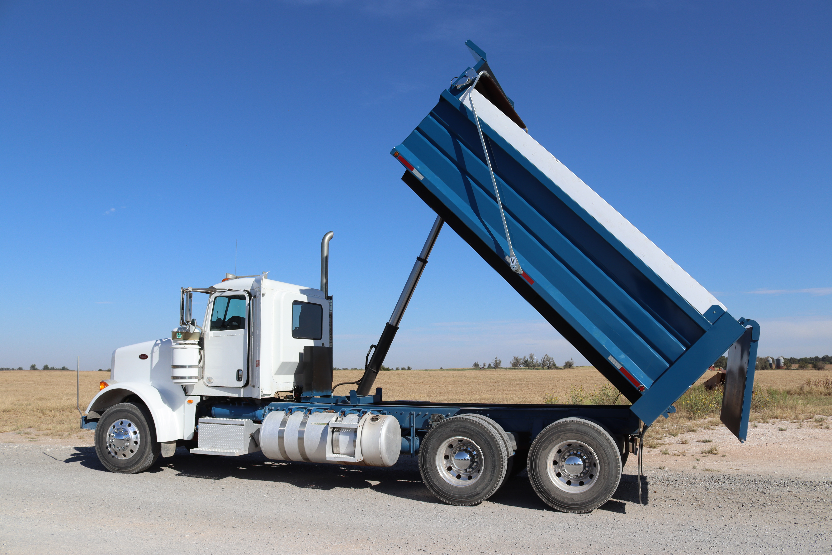When raising the truck box there is a risk of directly contacting an energized line which also energizes the truck and ground around the truck
* Another possible hazard is bridging electricity to the truck box energizing the truck and surrounding ground
* When working around energized lines there is the potential to lower the truck box onto wires of any kind which can result in pulling down the poles and lines onto the truck

*Ways to avoid these hazards:*

* When arriving onto the jobsite visually locate all overhead lines
* There are safe limits of approach for different voltage; know your limits
* Having a designated spotter is vital when working around overhead lines
* When possible create a designated drop zone away from all powerlines
* Ensure the truck box is lowered before moving the vehicle

*If your truck becomes energized:*

* Remain inside the vehicle
* Call 911 and inform them of the situation
* Inform others to stay away
* Wait for help and do not exit the vehicle

The only exception to staying in the truck is if it is on fire. In this case it will be necessary to jump from the truck landing on both feet. Do not touch the truck and ground at the same time. Then shuffle both feet as close together as possible for at least 30 feet.

